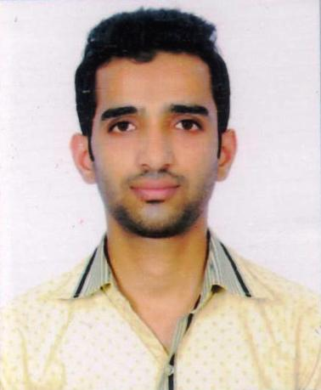 CURRICULUM VITAE

MOHD RUMAN SIDDIQUI

**Mail ID**: mohammadruman01@gmail.com

**Mobile**: +91-8800613069

CAREER OBJECTIVE

To start my career with an organisation that will utilize my skills and knowledge to benefit mutual growth and success.

ACADEMIC QUALIFICATION

* 10th ,A.W.F.A.I.C,Amroha, UP BOARD,2008:2ND DIVISION
* 12th ,A.W.F.A.I.C,Amroha, UP BOARD,2010:2ND DIVISION
* B.SC(PASS) ,JAMIA MILLIA ISLAMIA ,NEW DELHI, 2014 :1ST DIVISION

**TECHNICAL SKILLS**

* Programming Languages: C, Core JAVA
* Database: Oracle
* Basic knowledge of HTML, PHP.
* Worked on window7,window 8,Linux

COLLEGE PROJECT

* Developed an Acadmic Website As a Lab Assignment in graduation.
* Worked on a Family Events Management System as a minor project.

**EXTRA CURRICULAR ACTIVITIES**

* Participated in **BADMINTON MIXED DOUBLE** in **INTRA DEPARTMENT TOURNAMENT**  and won a **SILVER MEDEL**
* Co-ordinate in Campus Placement Cell at Jamia Millia Islamia

|  |
| --- |
| **STRENGTH** |

* Positive Attitude
* Leadership Quality
* Self Motivated
* Hard Working
* Always willing To Learn New Things

HOBBIES AND INTERESTS

* Playing & Watching Cricket, Badminton, Movies.

PERSONAL DETAILS

* Father’s Name : Late Mohd Suleman Ahmed
* Mother's Name : Afroz Begam
* D.O.B : 25/06/1994
* Nationality : Indian
* Address : R-95, 3rd floor, Gali No.-8, Joga Bai Extn, Jamia Nagar ,Okhla , New Delhi-110025

I hereby declare that all the above information details furnished are correct to best of my knowledge and belief.

**(MOHD RUMAN SIDDIQUI)**