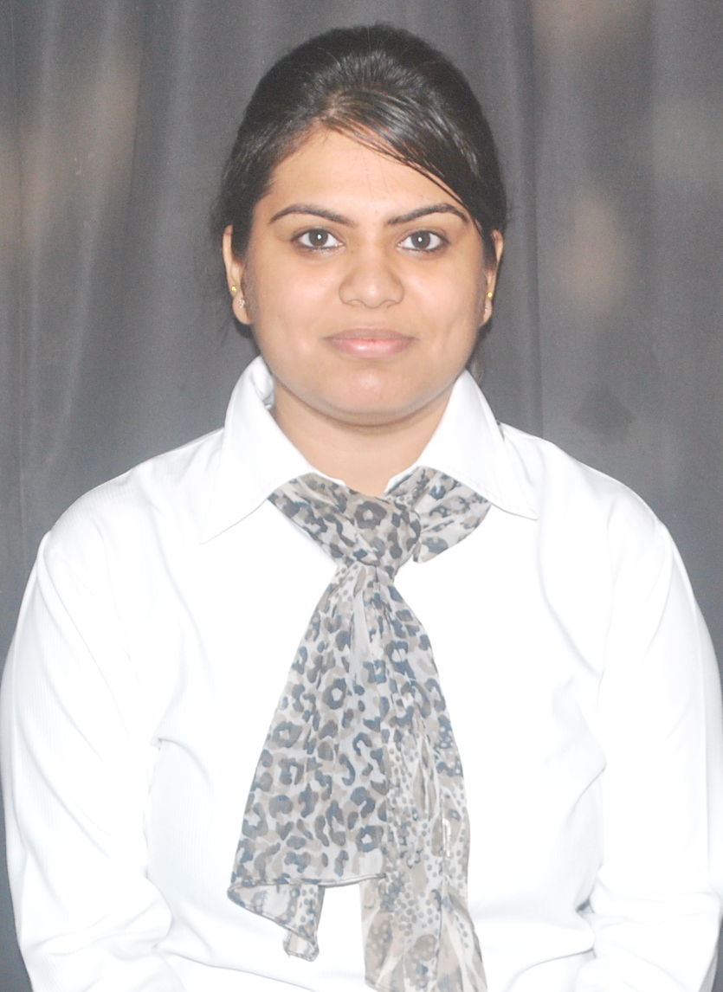

**Khushboo Arora**  
J-1/16 B Gupta Colony, Malviya Nagar, New Delhi – 110017, India   
**Contact:** +91-9711858087; **Email:** khushbooarora3@gmail.com; **Date of Birth:** February 3, 1992  
**______________________________________________________________________________________**

**Career Objective**A qualified Software Engineer, looking for an opportunity in a Multi-national IT Company which will help me deliver my best and upgrade my engineering skills and meet the demands of the organization.

**Technical Skills**Languages known: C, C++, C # (.net framework)  
Adequate knowledge of software development cycle models  
Well versed with various MS office tools.

Well versed with internet operations.  
  
**Educational Credentials**  
M.Tech Computer Engineering 2016(till 3rd sem) Manav Rachna College of Engineering, Faridabad 80.58%

B.Tech Computer Science Engineering 2014 Manav Rachna International University, Faridabad 75.8%  
Class 12, 2010 CBSE, New Delhi 69.8 %  
Class 10, 2008 CBSE, New Delhi 73.6 %

**Research Work**

Research done on “**Hybrid Approach for Optimizing Software Test Suite”**

**Description:** It’sa software tool which provides optimized test suite from the available test suite by using two AI techniques; Genetic algorithm and Ant Colony algorithm.

**Internship**Name of the Organization: HP Education Services (Jan 2013-June 2013)

Designation: Trainee

Location: Noida

Title of the Project: Electronic Store Core e-Portal

**Accountabilities**

Held with the responsibility of preparing an online shopping site used in e-commerce to assist people making purchases online and completed the same with the help of my hard working ability as per my Mentors.

**Accomplishments**

* Successfully completed the task and was appreciated for it.
* Secured A grade in the fulfillment of training.

**Projects undertaken as a part of Academic Curriculum**

* **Library Management System**

**Description**: Design and development of software on Library Management System using management using agile technology, Microsoft Visual Studio as front end and Microsoft SQL Server as back end.

**Review:** This project aims to automate the process of library management. The system helps to manage the details of books in an easy manner.

* **Hospital Management System**

**Description**: Design and development of software on Hospital Management System using Net Beans as front end and Microsoft Access as the back end.

**Review:**This project is aimed to develop to maintain the day –to-day state of admission/discharge of patients, list of doctors, reports generation, and etc.

* **Communication Tool for Disabled**

**Description**: Design and development of software on Communication Tool for Disabled using Microsoft Visual Studio as front end and SQL Server as backend.

**Review:** This project is aimed to help the disabled people communicate with each other. The technique is all about online chatting of the clients using text or gesture.

**Technical Training**Attended workshop on Agile Methadology as part of summer training.

Attended 6 months training on .NET from HP Education Services, Noida.

Attended 3 months training on C++ from A.E.C (Excellence in computer education), Delhi.

**Achievements and Commendations**  
Secured 7th rank in MDU in the 1st semester in M.Tech.

Secured ‘A’ grade in the industrial training.

Won 1st prize in Literacy school song competition in 2008 & 2009

Won 2nd prize in Inter-school Literacy song competition in 2005 and 2006.

**Co-Curricular Activities**

Participated and donated blood to Rotary blood bank.

Participated in group song competition.

*References available upon request.*