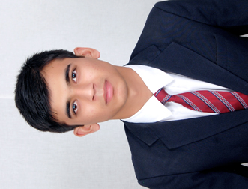

#3540 Gali No- 1/3 Shiv Colony

Karnal Hayana-132001

+91-9996912486, 8872033019

sainirohit64@gmail.com

Name: Rohit Saini

Course: BSc- ATHM

Specialization: 1. Searching Airfare 2. Tour Package 3. Handling Walking Clients

**ACADEMIC QUALIFICATION**

**Year Course Name of Board/University %age Division**

2013-2016 BSc (ATHM) University Institute of Hotel Management ---- ---

2013 XII C.B.S.E 69.4 1st

2011 X C.B.S.E 80 1st

**CORE COMPETENCIES**

* Good communication and interpersonal skills.
* Quick learner and a good team player.
* Having wholesome values of honesty.
* Have a healthy attitudes towards work

**INTERNSHIP**

**Company Name: Cox & Kings LTD** **Duration: 13 Jan 2015 – 25 May 2015**

**Roles and responsibility**

• Handling Walk-in Clients.

• Giving Tour Package Itinerary Details.

•Giving Airfare.

**HOBBIES/INTERESTS**

* Listening to Music.
* Athletics (Race).
* Quotation.
* Watching motivational movies.

**INTERPERSONAL SKILLS**

* Disciplined, dedicated and hardworking with an ability to easily adapt to changing work environments and technologies.
* Keen learner with ability to learn new knowledge with ease.
* Confident and Determined.
* Good presentation skills.
* Good team working ability.

**EXTRA-CURRICULAR ACTIVITIES**

* Participated in Creative Carnation contest held at university level in Chandigarh University.

**PERSONAL INFORMATION**

**Date of Birth: 19-09-1994** **Age:** 21

**Nationality:  INDIAN**                                           **Gender: Male**

**Marital Status:** Single **Religion: Hinduism**

**Height:** 5’-11’’                                                          **Weight: 60 Kg**

**Fathers Name: Sh. Satnam Saini** **Mothers Name: Smt. Meena Saini**

**DECLARATION**

I hereby, declare that the information furnished above is true to the best of my knowledge.

*(Signature)*

**Name:** Rohit Saini **Date:**