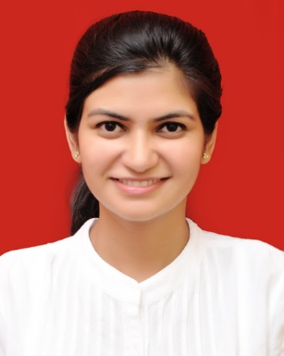

Geetanjali

9873775259

gitanjalir7@gmail.com

F-4/28-29 Sector-16, Rohini, Delhi-110089

OBJECTIVES

I would like to work for a professional managed company with a good organizational objective and friendly environment, which can provide me the right opportunity to serve & at the same time enrich me with the fresh and new experience which I keenly desire for.

PROFESSIONAL QUALIFICATION

* Pursuing M.B.A. in finance.
* Cleared CA-IPC Group-1 in year 2013

ACADEMIC QUALIFICATION

* B.Com(Hons.) from Delhi University in Year 2015
* 12th from Pratibha Vidhalaya in Year 2011
* 10th from Pratibha Vidhalaya in Year 2009

COMPUTER PROFICIENCY

* Working knowledge of windows and Internet, and familiar with MS-Word/MS-Excel
* Information Technology Certificate issued by ICAI.
* Power Point Tally Accounting Software (Version 7.2,9.0)

PERSONAL SKILLS

* A strong wiliness to learn new skills and abilities and observe perception.
* Like to interact with people to know them, understand and help them to solve their problems.
* Ability to work with team
* Initiative for taking new responsibilities
* Good communication, analytical and interpersonal skills.

PROFESSIONAL EXPERIENCE

* Book writing-manual as well as computerized using Tally Accounting Package (version 9.0).
* Maintaining books of accounts, Bank reconciliation statement, Debtors, Creditors Reconciliation statement. TDS Deduction, preparation of returns.
* Learn Basics of Audits.
* Knowledge in income-Tax matters, Finalization of financial accounts.
* Handling work related to income-tax like Computation of income-tax, filling returns, etc.
* Preparation of Annual Reports, Balance sheet and Projects Reports.
* Audits of finance companies and Non- trading concerns.

PERSONAL DETAILS

* Name- Geetanjali
* Nationality- Indian
* Marital Status- Unmarried
* Hobbies & Interest
  + - Reading books and novels
    - Listening to Music
    - Travelling
* Language Known- Hindi, English

Date: - Name-Geetanjali