**CURRICULUM VITAE**

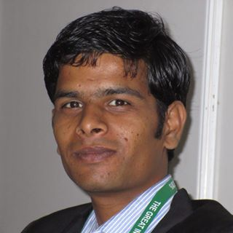

**SHIVAM BHAWSAR**

**CONTACT**

TEL: 09953256129

EMAIL ID: bhawsarshivam31@gmail.com

**CARRIER OBJECTIVE**

To work in Tourism Industry and grow the career with the experience earned, by giving the best of my knowledge and skills to the organization.

**CORE COMPETENCIES**

* Good communication skills (Hindi, English, Malvi, Bhojpuri, Telgu, Shekhavati )
* Convincing ability
* Adaptable to multicultural environments
* Interpersonal skills
* Dedication to work

**EXPERIENCE**

* Worked with Nepal pilgrimage travel (Kathmandu, Nepal) for one year (2011-12) in Domestic Department.
* Worked with Inspairerland Journey New Delhi.) (2012-14) in Domestic Operations Department.
* Now working with Colorful Vacations Pvt Ltd. Vaishali Ghaziabad in Domestic Operation Department from December.

**PROFESSIONAL QUALIFICATION**

* Completed Master of Tourism Administration from Banaras Hindu University (BHU), Varanasi

**EDUCATIONAL QUALIFICATION**

**Degree Board/University Name of Institution Year**

Graduation (B.A.) S.V.S.U. S.V. Subharti University, Meerut 2013

Intermediate (10+2) S.B.L. Dayalu Sanskrit Vidhyalaya, Varanasi 2010

High School (10th) M.P.B. Kalidas Vidhya Niketan, Soyatkala 2008

**ACTIVITIES OF INTEREST**

* OBT, IBT and Domestic
* Destination Marketing
* Product Designing and Marketing
* MICE

**EXTRA CURRICULAR ACTIVITIES / ACHIEVEMENT**

* **Coordinated the volunteers in GITB, Jaipur April, 2015**
* Volunteered various programmes organised during Budhva Mangle event conducted by Dept. of Culture. (U.P Govt.)
* Coordinated the transportation Committee National Symposium organised by Banaras Hindu University Varanasi.
* Actively involved in various programmes during the World Tourism Day Programmes organised by the Dept.

**TOURISM SKILLS**

* AMADEUS training for airline ticketing (offline)
* Itinerary & Costing skills for Tour Package designing
* Presentation skills for sales & marketing
* Event Management experience

**PERSONAL DETAILS**

* **Father’s Name** : Mr. Satish Bhawsar
* **Mother’s Name** : Mrs. Raj Kumari
* **Date of Birth** : 07 Feb 1994
* **Marital Status** : Unmarried
* **Nationality** : Indian
* **Gender** : Male
* **Language Proficiency** : Hindi, English, Malvi,Bhojpuri, Telgu, Shekhavati
* **Address**  : Ward no.- 8,Soyat kalan, P.O.-Soyat kalan,

Distt. - Agar, State- Madhya Pradesh

**DECLARATION**

I hereby declare that the above mentioned information is correct up to my knowledge and I bear the responsibility for the correctness of the above mentioned particulars.

**DATE:**

**PLACE:**

**Shivam Bhawsar**