**CURRICULUM VITAE**

** IRSHAD ALI**

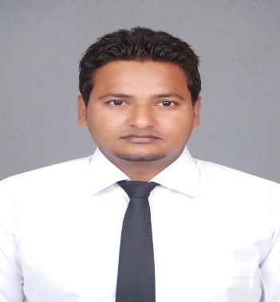

[irshad.ali444@gmail.com](mailto:irshad.ali444@gmail.com)

 +91-8899858447

Village and post Adoun,

Aligarh (UP) 202001

# CAREER OBJECTIVE

To give a practical shape to my theoretical knowledge and give the organization the best of my potential, capabilities and performance by continuous up gradation.

# ACADEMIC QUALIFICTION

|  |  |  |  |
| --- | --- | --- | --- |
| **COURSE** | **BOARD/UNIVERSITY** | **DIVISION** | **PASSING YEAR** |
| M.T.A. | A.M.U. | FIRST | 2016 |
| P.G.D.C.P. | A.M.U | FIRST | 2013 |
| B.SC. (HONS) | A.M.U. | SECOND | 2012 |
| SSSC-II | A.M.U. | SECOND | 2009 |
| SSC-II | A.M.U. | FIRST | 2006 |

# TECHNICAL SKILLS

* Operating System: Windows XP, 7, 8, 8.1.
* Tools: Microsoft Office (MS Word, MS Excel, MS PowerPoint)
* Fundamental Knowledge of Computer.

|  |
| --- |
| **EXPERIENCE AND TRAINING** |

* Dissertation On “***CRUISE TOURISM IN INDIA: POTENTIALS AND OPPORTUNITIES***”
* Training regarding **CRS “*ENTER THE WORLD OF AMADEUS*”** conducted by ***BIRD ACADEMY, Bird Education Society for Travel and Tourism*** in **Department of Commerce, 2016.**
* Training in ***“Computer Fundamental and MS Office”*** by **University Polytechnic AMU, Aligarh.**

# ACHIEVMENTS AND CURRICULAR ACTIVITIES

* Actively working as the member of NGO **“UDDHARAK – A Green Campus Initiative”.**
* Worked as Volunteer in **National Level HR** meet organized in AMU.
* Worked as Volunteer in University Convocation 2014.
* Worked as the volunteer in the Annual Hall Function.
* Got third prize in Photography competition organized by Deptt. of Commerce on World Tourism Day event.
* Organizing member of an event on World Tourism Day at Deptt. of Commerce.
* Certification of participation in quiz competition on the occasion of Sir Syed Day celebration.

# HOBBIES

* Reading current affairs books and magazine.
* Watching Movies.

# KEY STRENGTHS

* Positive attitude.
* Adaptability & flexibility.

# PERSONAL PROFILE

Father’s Name : Shamshad Ali

Mother’s Name : Razia Beghum

Date of Birth : 07 April 1990

Languages : English, Hindi & Urdu

Nationality : Indian

**Declaration:**

I hereby declare that the information furnished above is true to the best of my knowledge.

Date:

Place: **Irshad Ali**