**RESUME**

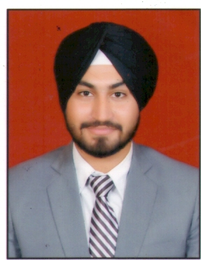

**JAPJIT SINGH KOHLI**

**MALE, 23 YEARS**

**WZ-214, G-Block, Hari Nagar, New Delhi-110058**

**Japjitsinghkohli@yahoo.com, +91-9650279193, +91-8586858628**

|  |
| --- |
| PERSONAL PROFILE |

Father's Name : Mr. Kawal Nain Singh Kohli

Date of Birth : 18 November 1993

Gender : Male

Nationality : Indian

Height/Weight : 178cm/70 kg

Languages : English, Hindi, Punjabi (Oral)

|  |
| --- |
| OBJECTIVE |

To find a stimulating and challenging role in clubs/hospitality where I can use my excellent interpersonal, management and leadership skills to make a positive contribution and confidently lead a team.

|  |
| --- |
| EDUCATION |

|  |  |  |
| --- | --- | --- |
| **Examination** | **Year** | **Institution** |
| Travel and Tourism | 2015 | Indira Gandhi National Open University |
| B.Sc. in Hospitality | 2015 | IHM, Chandigarh (Pusa) |
| 12th Board | 2011 | Holy Innocent School (CBSE), New Delhi |
| 10th Board | 2009 | Holy Innocent School (CBSE), New Delhi |

|  |
| --- |
| PROFESSIONAL EXPIRIENCE |

* **Worked as Reservation Associate for 1 year at The Oberoi Hotels & Resorts for 1 year.**
* Processes reservations by mail, telephone, telex, cable, fax or central reservation systems referral received from the direct guests, sales office, other hotel departments, and travel agents.
* Knows the type of rooms available as well as their location and layout.
* Knows the selling status, rates, and benefits of all packages plans.
* Knows the credit policy of the hotel and how to code each reservation.
* Creates and maintains reservation records by date of arrival and alphabetical listing.
* Promotes goodwill by beings courteous, friendly, and helpful to guests, managers, and fellow employees.
* Additional duties includes preparing the list of expected arrivals for the front office.
* **Worked as Team Co-ordinator in WINGS Pvt. Ltd for 3 months.**
* Learnt to develop strong working relationships with clients and guest via direct communication.
* Worked with external vendors to ensure high standards for service quality.
* Updated information and communications in the database.
* Assisted with member-guest related events to ensure all the meeting needs are met.
* **6 months training in all departments in METROPOLITAN HOTEL, New Delhi**

|  |
| --- |
| EXTRA CURRICULAR ACTIVITIES AND QUALIFICATIONS |

* Participated in numerous Inter School Drama competitions at school level.
* Active participation in leadership development activities in school like Environment club, Drama club, Social work etc.
* Learnt basics of Tae-Kwon-Do.
* Interested in making music.

|  |
| --- |
| OTHER SKILLS |

* Knowledge of Microsoft Office Outlook
* Knowledge of Microsoft Office Suite
* Knowledge of Opera

|  |
| --- |
| STRENGTH |

* Ability to grasp thing in short time.
* Honest & Punctual.
* Hard working & inculcate true Team Work spirit.

(JAPJIT SINGH KOHLI) Date:

Place: