# RESUME

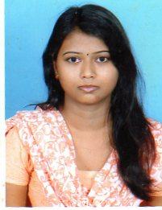

# Kiran Kumari

# Contact No. : 9304196344

# E-Mail : s.kirankumari@rediffmail.com

**CAREER OBJECTIVE**

Become a part of your reputed and esteemed organization and serve you with best of my skills to give you satisfaction up to your expectation in any work being provided to me related to my area of my work and skills.

**ACADEMIC QUALIFICATIONS**

* Post Graduate (M.Com.) in Finance from Jamshedpur Women’s College an autonomous College of Kolhan University with 74.79% marks. (Passed in 2011).
* Bachelor of Commerce (Hons.) from Graduate College (by Ranchi University), Jamshedpur. With 61.50% marks. (Passed in-2009).
* Completed Higher Secondary education (10+2) from Graduate College (by JAC Board, Ranchi), Jamshedpur. With 65.40% marks. (Passed in 2006).
* Completed Secondary education (10th) from D.A.V.Sonari (by JAC Board, Ranchi). With 62.80% marks. (Passed in 2004).

**COMPUTER PROFICIENCY**

* Pro-efficient with Microsoft Office (Word, Excel and PowerPoint).
* Proficient use of Internet.
* Tally 6.2, 7.2 and 9.0 version.

**WORKING EXPERIENCE**

* As Data Entry Operator at Bistupur Post Office for six months.
* As Accounts Asst. At All India Women’s Conference ( N.G.O ), Jamshedpur const. Branch. For Last 4 Years.

**JOB PROFILE**

* Making Sale Bill.
* Reconciliation of Bank Statement.
* Journal Entries.
* Purchase Entry of all bills including Leather purchase bill (Shortage & rejection report).
* Sales Tax & making various statement related to Sales Tax return filling.
* Suppliers Payment Statement.
* Payment Entry.
* Attendance update of A.I.W.C Employees and Contractual Employees Of Tata Steel.
* Creating Salary of Gloves Section.

**PERSONAL DETAILS**

Father’s Name : Late Dulare Lal

Date of Birth : 06th June, 1988

Permanent Address : H. No. 1168, B/Block, Pardesi Para, Sonari, Jamshedpur-831001

Nationality : Indian

Religion : Hindu

Sex : Female

Marital Status : Single

**PERSONAL INTEREST**

* Listening Music
* Travelling.

DECLARATION

I hereby confirm that all the information provided in the Resume stands true as far as my knowledge is concerned.

**Date:20.02.2016** 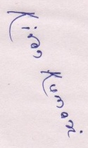

**Place: Jamshedpur** **(KIRAN KUMARI)**