CURRICULUM VITAE

Sunny Bedi

H.No-4206 Ajit nagar,

Gandhi Nagar Delhi-31

Cont.8826064900

Email Id-Sunny.Bedi03@gmail.com

**Career Objective**

### My Career objective is to achieve mutual benefit for employing organization and myself through commitment. Hard work and persistence & utilize my knowledge.

### Personal Profile

**Date of Birth :-03/05/1995**

**Father’s Name :-Mr. Pradeep Singh Bedi**

**Nationality:-Indian**

**Sex :-Male**

**Language Knows:-Hindi ; English& Punjabi**

**Academics**

* **10thPassed from C.B.S.E Delhi**
* **12thPassed from C.B.S.E Delhi**
* **Pursing B.com (hons) from University of Delhi**
* **Pursuing company secretary from ICSI**

**HOBBIES**

* **Playing cricket**
* **Liseting music**
* **Reading Newspaper**

**PERSONAL STRENHTS**

* **Quick learner and result oriented**
* **Hardworking energetic and sincere**
* **Positive thinker**

**COMPUTER KNOWLEDGE**

* **Basic Computer Knowledge**
* **Good Working knowledge of MS- Word, Excel and Power Point.**

**Work Experience**

* **1 Year experience of Promotional Events like Britania for 1 month, Vodafone and TaTa Photon for 1 week and some other event of different company etc.**
* **1 Year experience of marketing research in Accel knowledge in 2015 job profile is field market research.**
* **1 Year Experience of sales and marketing in Konsult App Pvt. Ltd. (healthcare co.) from Aug 2015 to present working job profile is client meeting**

**Declaration**

**I hereby declare that the above information is true to best of my knowledge.**

**Date:……………**

**Place:……………**

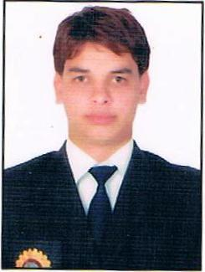

(Sunny Bedi)

