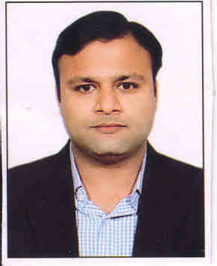 **MANUJ KUMAR SINGHAL**

Mobile: +919953801328

Address: A-701, Jaipuria Sunrise Greens,

Indirapuram, Ghaziabad

**Profile**

A creative and enthusiastic person with a diverse range of Sales and Customer Services experience. Outgoing with strong and effective sales, organizational, communication skills. Good team player and able to use own initiative to achieve company objectives. Excellent computer skills, versatile and learns new tasks and skills quickly.

**Vision**

Seeking a challenging career as a professional in the firm where my skills are better utilized and there is a huge growth prospectus, assure that my commitment towards my job would file better results.

**Work experience**

From July 2007 to July 2008, I worked as a Relationship Officer with RAKBANK in Dubai, U.A.E. I was into Retail Banking in CREDIT CARD SALES.

Job Description

• Set targets for week, month and year.

• Achieve targets as per commitments.

• Meeting new customers.

• Taking references from old customers.

• Generating leads from old customers.

• Responding to all inquiries of customers.

• Using different and creative type of media and ideas to achieve targets.

• Maintain healthy & Professional relationship with the individual &corporate customers.

• Maintain key corporate accounts through proper understanding their needs and demands.

• Cross sale other products.

• Collecting all proper and required documents from customers.

• Preparing daily sales reports.

• Reporting to relationship manager.

From November, 2008 to June, 2011 I worked with Barclays Shared Services Private Limited (a subsidiary of Barclays Bank Plc.) as a Customer Care Executive.

Job description

• Handled queries quickly and accurately by attending Inbound and Outbound Calls.  
• Assisting Customers in making Payments of all types, Domestic & International.  
• Applying the set of Procedures to check that the payment is not related to any restricted Individual or Entity.  
• Maintained close contact with customers and managed client files.   
• Prepared various operational, proofs, and accounting adjustments.  
• Resolved dissatisfied customer complaints.  
• Assisted and responded to customer's inquires and complaints.

• Constantly monitored transaction characteristics and account changes.

From October 2013, I have been working as a Freelancer in Real Estate till date.

**Educational qualification**

Passed Intermediate 12th (PCM) from Dayawati Modi Public School, Modinagar in 2001.

Certification in Computerized Reservation System(Amadeus) from TMI Academy, New Delhi.

**Software skills**

Packages : MS office, Windows 7

**Personal Details**

Father’s name : Mr. A.K. Singhal

Date of birth : 10th May 1983

Nationality : Indian

Sex : Male

Religion : Hindu

Languages known : English, Hindi

E-mail Address : [Manuj.singhal10@gmail.com](mailto:Manuj.singhal10@gmail.com)

[Manuj.singhal10@rediffmail.com](mailto:Manuj.singhal10@rediffmail.com)

Marital Status : Single

(Manuj Kumar Singhal)