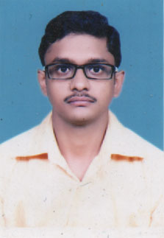**Mayank Srivastava**

Email – srivastava.mayank3838@gmail.com

Mobile no:-7060384956

**CAREER OBJECTIVE**

To put my abilities and learning skills to best use and make my effective contribution to an organization for a bright and rewarding career.

**EDUCATIONAL QUALIFICATION**

1. Pursuing MCA from MIET College, Meerut
2. Completed BCA From UNITED INSTITUTE OF MANAGEMENT in year 2014 with 58%
3. Completed 12th from ISC Board in year 2011with 55%
4. Completed 10th from ICSE Board in year 2009 with 57%

**ACADEMIC PROJECT**

**Project Name**: Hospital Management

**Language Implementation**: HTML PHP

**Data base**: SQL

**Operating system**: Windows 8, Windows 7

**Responsibilities:**

Write SQL query in data base

Creating Designing Part

**EXTRA-CURRICULAL ACTIVITIES**

* Host the cultural activities of college & school.
* Participated in college activities actively.

**PERSONALITY TRAITS**

1. Sincere, Punctual, Co-operative
2. Positive attitude, good team spirit and hardworking capability

**PERSONAL DETAILS**

Father’s Name : J.P. Srivastava

Date of Birth : 07 OCT 1992

Marital Status : Single

Languages : Hindi & English

Area of Interest : Listening Music, Playing Cricket

Permanent Add : 109l/3b/1 Beniganj Allahabad

**DECLARATION**

I hereby declared that all the above details are true and correct to the best of my knowledge

**Place -** Allahabad (**Mayank Srivastava)**