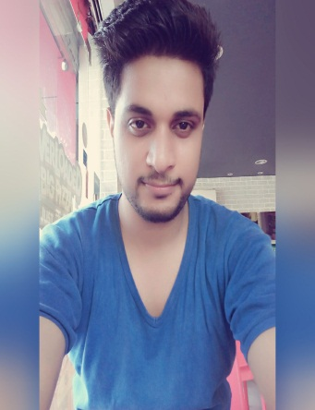

YOGESH KUMAR

RZ-15,Gali No-19,Vashisht Park

Sagar Pur,New Delhi-110046

Email.ID ([Kumaryogesh387@gmail.com](mailto:Kumaryogesh387@gmail.com) **)**

Mobile. No. – (9013676044,9716282747)



**OBJECTIVE**

I can best utilize my skill and contribute towards the growth of the organization.

I want an become an Accountant.

**Professional Qualification**

* Certified Industrial Accountant.

**Qualification Details**



* Pursuing B.com from Delhi University.
* Passed 12th From, M.C.L.S.B.M School Hari Nagar, New Delhi, C.B.S.E Board.
* Passed 10th From, M.C.L.S.B.M School Janak puri, New Delhi, C.B.S.E Board.

**WORK EXPERIENCE**



* Working as Data Management Assistant in NIC (National Informatics Centre) for NCM (National Commission for Minority).
* 10th month’s in India Mart as Customer Care Executive.
* 12th month’s in Effort BPO Ltd.

**PERSONAL DETAILS:**



* Date of Birth : 20th september1994.
* Father Name : Late Shyam Lal.
* Marital Status : Unmarried.
* Nationality : Indian.
* Sex : Male.
* Hobbies : Playing Volleyball, Hang out with friends
* Language known : Hindi & English.

Date: ___________

Place: New Delhi (YOGESH)