**Curriculum Vitae**

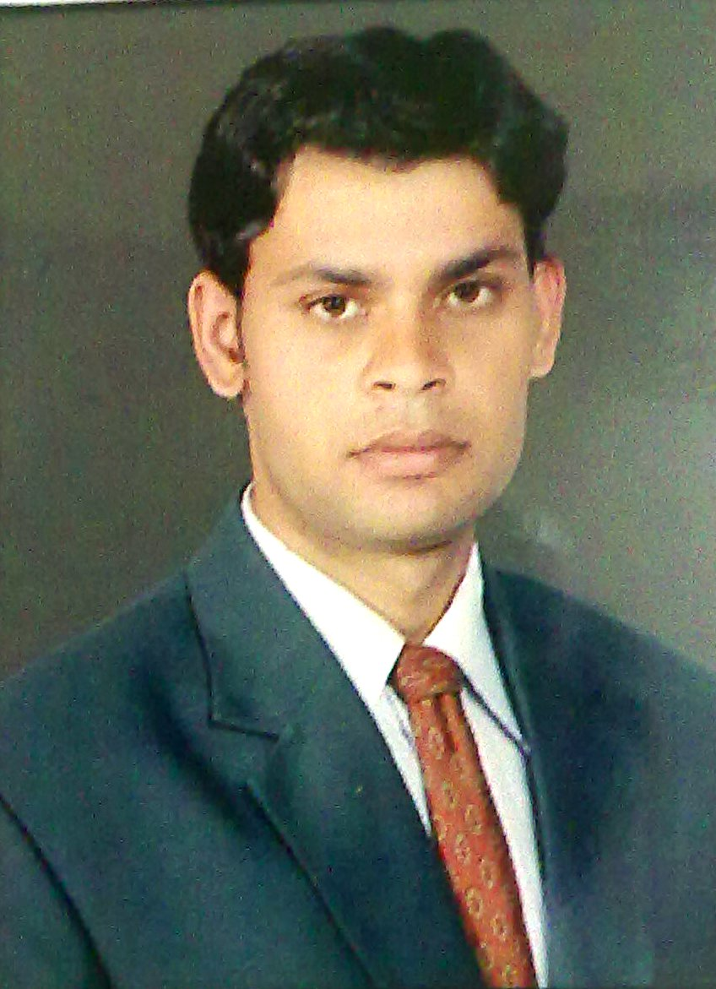

**VIKAS SHARMA**

**(M)** **:08561953801,08690162914.**

**Vikassharma.alesco@gmail.com**

**Specialization:**

**Financial Management.**

**Marketing Management.**

**Career Objective**

To pursue a career with an organisation having a global vision, which encourages creativity and offers an opportunity to learn and develop in professional life, and enhances my knowledge and ability to work in groups.

**Professional Qualification:**

* MBA from Maharishi Dayanand University (Rohtak-HR) 2009-2011. (Specialization: Finance.)
* PGP From Alesco Business School,(Indore- M.P) 2009-2011. (Specialization: Marketing.)

**Education Qualification**

|  |  |  |  |  |
| --- | --- | --- | --- | --- |
| **Class** | **Year** | **Board/University(College)** | **Subjects** |  |
|  | | | | |
| B.com | 2008 | Rajasthan University, Jaipur  (S.K College sikar) (Raj.) | Business admin., A/C& Law, Business Economics |  |
| 12th | 2005 | Rajasthan Board, Ajmer  (S.K school,sikar) (Raj.) | English, Hindi, Economics, Business org., Accountancy |  |
| 10th | 2003 | Rajasthan Board, Ajmer  (Tegore Bal Nekiten school) (Raj.) | English, Hindi Maths, Social Sc., Science. |  |

**Summer Internship –Systematix share & stock India ltd.**

**Objective -** To Analysis of share and open Demat and Trading A/c.

**Achievement:** Company gave me a Target for opening TEN Demat and Trading A/c and I have achieved this target in a given span of time.

**Computer Skills**

**Operating Systems:** Windows

**Packages Known:** MS Office (Word, PowerPoint, Excel)

**Additional Qualification**

* **Career oriented course**
  + - **(Short hand steno)**
    - **(Typewriter Hindi and English).**

**Working Experience**

* **I have 2 years Experience in LBF Books Publication Pvt. Ltd. Bhilwara (Raj).**
* **Promote of Book and Convert into the Sale.**
* **Now I am working in MEWAR Orthopaedic Hospital Pvt. Ltd.(Accounts Manger)**

**Personal Details**

**……………………………**

**Date of Birth:** 04/06/1988

**Marital Status**: Single

**Languages**: Hindi & English.

Parmanent Addresss:

* **Vikram Gas Godown, Radhakishan Pura,Sikar.332001(Raj.)**

**Date:**

**Place: (VIKASH SHARMA)**