**Naila Khan**

**Phone:** +91-8447731602

**E-mail:** [khan.naila1989@gmail.com](mailto:khan.naila1989@gmail.com)

**Address: -** C-24/3, Jamia Nagar, New Delhi-110025

## Career Summary

## Currently working as, Assistant Manager – Sales Operations.

## An perceptive and result oriented professional with 5 years of extensive experience in Business Development, Sales & Marketing, Customer relationship Management.

## A proactive leader and planner with expertise in planning, market plan execution, sales effort with skills in competitor and market analysis. Building consensus, and working effectively within cross skilled.

## PROFESSIONAL SYNOPSES AND PERFORMANCE

**Oct 2010- Till Date**

## Current Responsibilities

**Organization : Investors Clinic Infra-tech Private Limited.**

**Designation : Assistant Manager – Operations.**

**Company Profile: -** Investors clinic is an ISO 9001:2000 certified company, dealing with all type of property from industrial property and commercial property to residential property and farmlands, Investors clinic is authentic residential property dealer and broker agent in Noida/NCR

## Key Expertise & Competencies

**BUSINESS DEVELOPMENT SKILLS:**

* Responsible for **Managing Builder Relations** with Leading 60+ Builders for their Projects across India with major focus on Gurgaon and Noida.
* Organized strategic marketing events for product selling and extracting market demands. Accordingly expanded product lines and various new Payment options plans based on customer needs assessment and market research.
* Customer relationship management.

**MANAGEMENT AND LEADERSHIP SKILLS:**

* Assigned to Head Backhand support team through Day to day coordination with sales team helping them by providing the right information on project costs, guidance and advice to support sales to enhance the activities contributing to Sales management.
* Inventory Cycle Management
* Reporting and Performance Management
* Team Building Management.
* Impressive presentation and interpersonal skills.

**TECHNICAL AND PRESENTATION SKILLS:**

* Microsoft Office (Excel/Word/Power point
* Linux/Windows (OS), Oracle STS (inventory management),
* LMS (lead management System) and CRM Management.

## Achievements

* **Achieved Best Employee in Coordination award for the year 2011-12 and 2013-14.**
* **Established quality standards for various operational areas.**
* **Awarded Top Performer for Project handling of Jaypee Studio Apartments and Lotus.**
* **Did a successful internal commission process check with Ernst & Young.**
* **Deliver maximum output with various Developers- Lotus, JP, Mahagun, Amrapali etc. And such output has proven to be the maximum result oriented in the company history.**
* **Plan and developed develop various customer service strategies and managing their escalations through swift solutions.**
* **Planned a complete process of Sales Operation team resulted in management of database of each booking done and its final status.**
* **Managed and delivered 100+ Projects/Assigments single handedly.**

**Personal Growth Chart: -** 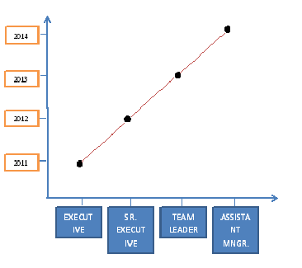

## Academic & Professional Qualification

* MBA (HR and Retail), Gauhati University, Year 2009-2011. (Scored - 89%)
* BA, Delhi University, 2006-2009. (Scored - 68%)

## Personal Information

Fathers Name Mr. Achhan Khan

Date of Birth 31-Mar-1989

Gender Female

Nationality Indian

Languages English, Hindi, Urdu

Marital status Single

**DECLERATION:** I do hereby declare that the particulars of information and facts stated herein above are true, correct and complete to the best of my knowledge and belief.

**NAILA KHAN**