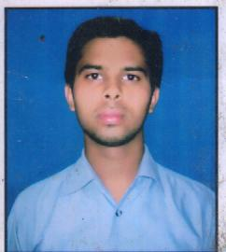 **RESUSE**

Vill:-bishanpur

Post iglas Dist-aligarh

PIN-202124

Mobile: +91-9756328279

**VINAY KUMAR**E-mail: [kataravinay5@gmail.com](mailto:kataravinay5@gmail.com)

**CAREER OBJECTIVE:**

* To do my job with full of dedication and the best use of my essential knowledge, experience, skills to take the company to new heights.

**EDUCATIONALQUALIFICATION:**

* Passed 10th fromU.P. Board, Allahabad in 2007.
* Passed 12th fromU.P. Board, Allahabad in 2009.
* Passed Graduation (B.Pharma) from U.P.T.U. Lucknow in 2013.

**COMPUTER SKILLS:**

* Basic knowledge of Computer.

**EXPERIENCE:**

* Working in fdc ltd from 7hnov 2013 to 10th apirl 2015. At Hathras H.Q.
* Working in Unichem Labs from 13 april 2015 to till Now. At Aligarh H.Q.

**STRENGTH:**

* Hardworking & Sincere
* Punctual
* Positive Attitude

**HOBBIES:**

* Listening Music
* Travelling

**PERSONAL DETAILS:**

Father’s Name: Sh. Prakash Chandra

Date of Birth: 15/03/1992

Nationality: Indian

Marital Status: Unmarried

Language Known: English, Hindi

Recommended by- Jitendra Tanwar

I hereby declare that the above information are complete and correct through the best knowledge of my belief.

**Date: ……………**

**Place: …………**

**(VINAY KUMAR)**