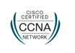 **CURRICULAM VITAE**

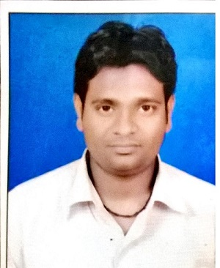

**MD SHAMIM ANSARI**

**S/O: - MD SALIM ANSARI**

**E-Mail Address :- shamimakhtar178@gmail.com**

**Contact :- +91-9504766447 , 7480012162**

**Post Applied For :- Network Technician / IT Technician**

***Objective:*-**

**To constantly seek knowledge and climb the ladder of success with combination of smartness and hard work. Utilize my skills to give best. I have always endeavored to maintain a good throughout the career.**

***Education Qualification:-***

|  |  |  |  |  |  |
| --- | --- | --- | --- | --- | --- |
| **Examination** | **Board/University** | **Year of Passing** | **Percentage** | **Division** | |
| **Matriculation** | **J.A.C., Ranchi** | **2007** | **62.4** | **1ST** | |
| **Intermediate(I.Sc)** | **J.A.C., Ranchi** | **2009** | **48.04** | **2ND** | |
| **Graduation** | **V.B.U. Hazaribag** | **2014** | **47.67** | | **2nd** |

**JOB RESPONSIBILITIES :-**

* **Responsible for configuring and installing Cisco switches and routers.**
* **Setting up network cabling from rooms to switch, with labelling to trace problems if issues raises.**
* **Install hardware, software and device drivers on standalone computers**
* **Install and configure computer networks including LAN and WAN**
* **Manage network configurations to ensure that all computers on a network can communicate effectively**
* **Test computers peripherals, hardware and software to ensure that they are working appropriately**
* **Upgrade software, patches and operating systems on a continuous basis**
* **Install and configure monitors, keyboards and printers**
* **Troubleshoot hardware and software problems**
* **Act as a technical resource in order to assist users with resolving computer issues**
* **Ensure that all computers are secured effectively by installing and updating**
* **Analyze network problems and manage preventative maintenance procedures**
* **Explain the role of network applications and equipment to the end users**
* **Manage user data backup and restore.**

**INTRODUCTION :-**

* **Having 6 Years Professional Experience in India.**

**WORK EXPERIENCE IN DETAILS:-**

**Name of the Company : - MINESOURCEINDIA PVT. LTD**

**Designation : - SERVICE ENGINEER**

**Location : - KOLKATA,C.I.L BCCL DHANBAD**

**Duration : - Feb 2011 to Till Date.**

1. **HIGHER Diploma in SYSTEMS NETWORKINGS.**

* **CCNA (NETWORK)**
* **Computer Concept & Fundamentals**
* **Dos (Disk Operating System)**
* **Windows XP, Windows VISTA , Windows 7 , Windows 8.1 ,Win 10**

**Linux , Server 2003 , Server 2008.**

* **MS-Office: (Word Excel, Power-Point)**
* **New Technology**
* **Internet & e-mail Technology with Multimedia**

**PERSONAL DETAILS** :-

**Name : - Md. Shamim Ansari**

**Father’s Name : - Md. Salim Ansari**

**Nationality : - Indian**

**Sex : - Male**

**Date of Birth : - 08-03-1992**

**Religion : - Islam**

**Language known : - English, Urdu & Hindi**

**PASSPORT DETAILS :-**

**Passport No. : - N2377296**

**Date of Issue : - 01/09/2015**

**Date of Expiry : - 31/08/2025**

**Place of Issue : - Ranchi, Jharkhand**

**PERMANENT ADDRESS :-**

**Md. Shamim Ansari, S/o. Md.Salim Ansari,**

**Lodna Islampur, Post:- Lodna, Dist:- Dhanbad,**

**State:- Jharkhand 828131, Country:- India**

**I hereby certify that all above stated information in true and correct to the best of my knowledge and belief.**

**Date:**…………………

**Place:**………………..

**MD. SHAMIM ANSARI**