**RESUME**

Vijendra Kumar Kushwaha 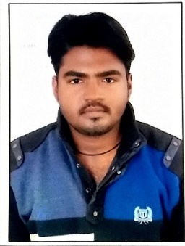

Biloungi L.I.G-41,WaidhanDistt-Singrauli(M.P)Pin-486886

Phone No - 9479712512

Email – [vickey.kush415@gmail.com](mailto:vickey.kush415@gmail.com)

**Objective:**

To work in the environment which will enhance my skills as well as extract the best out of me so as to achieve organizational goals and also provide a growth path to my career.

**Educational Qualifications:**

|  |  |  |  |  |
| --- | --- | --- | --- | --- |
| **Degree** | **School/College** | **Board/University** | **Year of Passing** | **Percentages (%)** |
| M. C. A. | Lakshmi Narain College Of Technology, Bhopal | RGPV University,  Bhopal | 2016 | 7.8  (CGPA) |
| B. C.A | ShriSaiMahavidhyalaya,Vindhyanagar | APS Rewa University | 2014 | 71.3 |
| Higher Secondary | St.Joseph’sHr,SecSchool,Waidhan | I.S.C Board | 2011 | 48.8 |
| High School | St.Joseph’sHr,SecSchool,Waidhan | I.C.S.E Board | 2009 | 43.1 |

**Technical Skills:**

|  |  |
| --- | --- |
| **Operating System** | Win 7,Win 8,Win 10 |
| **Programming Languages** | Core Java |
| **Database** | Elementary Knowledge OF MY SQL. |

**Subjects of Interest:**

* Android Developer.

**Working Experience:**

* I am working in **Everlight Realcon infrastructure limited.** I was working with 2 year As Confirm Employee .I was working in Back Office as Office Assistant. I was donning data entering.
* 15 Day of Working in Hindalco Mahan as a Backup Support Computer Engineer on with Wipro team.

**Personal Details:**

Date of Birth 14\02\1993

Father’s Name Mr Surya Bali Kushwaha

Mother’s Name Mrs Geeta Devi

Language Known English, Hindi

Hobbies Play piano or keyboard, Travelling, Watching movies.

I do hereby declare that the information furnished above is complete and true to the best of my knowledge.

**Date:20/03/16 Vijendra Kumar Kushwaha**

**Place:Waidhan**