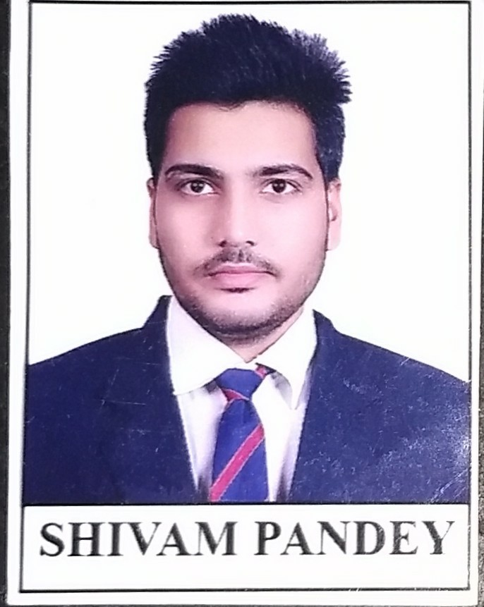Shivam Pandey

E-mail :shivampandey9721@gmail.com

DOB : 12 Aug’1997

Contact : +918982558094

Address: 69 Shakarpur khas East Delhi 110092

CAREEROBJECTIVE:

To build my career in a progressive organization that will provide me exciting opportunities to learn and accelerate my skills.

EDUCATIONALQUALIFICATIONS:

|  |  |  |  |  |
| --- | --- | --- | --- | --- |
| **DEGREE/COURSE** | **COLLEGE/SCHOOL** | **UNIVERSITY/B OARD** | **YEAR OF PASSING** | **AGGREGATE/PER CENTAGE** |
| B.E  (Electrical & Electronics) | Oriental College of Technology, Bhopal | R.G.P.V | 2019 | 67 |
| 12th | MadhavGyanKendra, Naini,Allahabad | U.P. Board | 2014 | 82.2 |
| 10th | Gopal Vidyalaya Inter, Allahabad | U.P. Board | 2012 | 82.6 |

**TECHNICALEXPOSURE:**

|  |  |
| --- | --- |
| **PROJECT 1.** | * **Flying Public Announcement System** * Description : this is completely focuses on a Flying Public Announcement System using UAV drone is an aircraft without a human pilot aboard. UAVs are a component of unmanned aircraft system (UAS); which include a UAV, a ground-based controller, and a ystern of communications between the two. |
| **PROJECT 2.** | * **GSM based Substation Monitoring and Control System** * Description : GSM-Projects Monitoring and controlling of substations are essential task for supplying healthy power to the consumers in this automated era. Depending on the voltage levels and end users, there are transmission or distribution substations those supply electrical power to various loads. |
| **PROJECT 3.** | * **Solar Tracker** * Description: solar panels are stationary and do not follow the movement of the sun. Here is a solar tracker system that tracks the sun's movement across the sky and tries to maintain the solar panel perpendicular to the sun's rays, ensuring that the maximum amount of sunlight is incident on the panel throughout theday. |
| **INDUSTRIAL TRAINING** | **132KV Substation training (UPPTCL Naini,Allahabad)**(Four Weeks) - Study included type of substitution, layout of substation, design of busbar, transformer, circuit breakers and protective relay. |
| **INDUSTRIAL VISIT**  **(As a Part of Academic curriculum)** | * Dewas Wind Mill Power Plant-Study of Generation of   Electricity through wind mills (15 MW generation plant)use of wind-a Renewable source ofenergy.   * Crompton Greaves,Bhopal * C.P.R.I,Bhopal * Govindpura substation,Bhopal |

**TECHNICAL SKILLS&PROFICIENCY:**

* Basic C language
* MS Office
* MS Excel
* RHEL linux
* Networking
* Embedded system

PERSONAL TRAITS&HOBBIES:

* Good Managerial skills
* ATeam Player(very cooperative with colleaguesinany situation or emergency)
* Adaptable & Flexible
* Good Communication skills
* Hard working and persistent
* Optimistic & a quick learner
* Travelling

**Work experience:**

01.09.2019 - 31.11.2021

Telecommunication Engineering Centre ,New Delhi

**Designation –** Technical Support engineer

**Role & responsibilities –** working on RHEL Linux operating systems V8.4, configure Commands and managing system backups and adding and removing users, managing word documents & excel sheet.

**ACADEMIC ACHIEVEMENTS AND EXTRA CURRICULARACTIVITIES:**

* Participated in various events held at Tech fest in Oriental College of Technology, Bhopal.
* Participated in Embedded workshop inTech Acme 2016
* Participated in quiz through out thebcollege in tech-fest.

I hereby declare that all the above mentioned information are correct up to my knowledge.

Date:

SHIVAM PANDEY