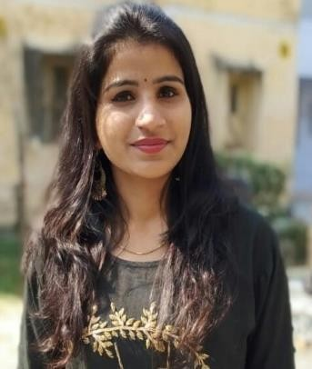

**NAME : PRAGYA MISHRA**

E-Mail: [pragya321mishra@gmail.com](mailto:pragya321mishra@gmail.com)

Address : A-255,Sanchar Vihar ,ITI Township mankapur ,GONDA ,UP -271308 ContactNo.:8210194730

**WORK EXPERIENCE**

* I am working with weboconnect technologies pvt.ltd since 1st march 2020.

**ROLES & RESPONSIBILITIES**

* I am handling Hr generalists as well as whole recruitment process including sourcing, screening, scheduling, selection, negotiation, onboarding, joining formalities, documentation, and induction and orientation program.
* I am also into content writing part for the company’s website like blog, classified, Meta description.
* I am managing linkedIn, facebook, twitter for article writing and social media posts.
* I work on indeed, naukari.com and linkedIn for sourcing candidates profile.
* I have recruited non-IT candidates and IT candidates for the profile of Developers, graphic designers, .NET, SEO, digital marketing, content writers, Angular, Node js
* I coordinate with sales and business development team for generating client leads from LinkedIn and other for the projects.
* I worked with Concentrix Daksh pvt ltd from June’2019 till 28th February 2020 as a Representative Advisor-1.

**ROLES & RESPONSIBILITIES**

* I was working as a business development associate of Amazon as partner side.
* I was handling the queries of Amazon’s selling partner via e-mail, phone and chat process.
* I was trained to provide support to the seller regarding their payments, stock keeping, and sales.

# EDUCATION QUALIFICATION

* MBA – Central University Of Jharkhand (2017-2019) – 83.2%
* BBA – Central University Of Jharkhand (2014-2017) – 70.04%
* Intermediate - St. Michael’s Convent School(2014) – 76.2%
* Matriculation - St. Michael’s Covent School – 72.2%

# KNOWLEDGE AND SKILLS

* Knowledge of basic computer and doing certification course of advance excel from Udemy.
* Performed roles during internship program like sourcing candidates (IT & non-IT) from portals, screening, scheduling, follow-up, negotiation, onboarding, documentation.
* Participated in employees engagement activities, exit interviews, off boarding, induction, orientation programs.
* Proficient in oral and written presentation and communication skills.( Hindi and English)
* Experience of grievance redressal process and conflict management skill.

# PROJECT DETAILS

* **PROJECT TITLE: A study on Welfare facilities and satisfaction of employees”.**

Organization: INDIAN TELEPHONE INDUSTRY Location: GONDA (UP)

Duration: 1 MONTH

* **PROJECT TITLE: A study on CSR and Whistle blower policy”.** Organization: ROHIT SURFACTANT PRIVATE LIMITED Location : SAGAR(MP)

Duration: 1 MONTH

* **PROJECT TITLE: “Employees Engagement as a Retention Strategy”.** Organization : IQOR GLOBAL SERVICES INDIA PRIVATE LIMITED Location: MANESER

Duration: 2 MONTHS

**EXTRA CURRICULAR ACTIVITIES**

* Participated in state level “handball tournament”.
* Participated in singing and dance competition.
* Participated in Global Entrepreneurship Summit
* Attended a workshop on “Referencing Tools”.
* Participated in HR conclave.
* Participated in trail blazer at CUJ
* Attended a session on stress management

# PERSONAL DETAILS

Date of Birth: 14th December 1996

Marital Status: Unmarried

Sex: Female Nationality: Indian

Languages Known: Hindi and English

Strength: Enthusiastic, perseverance, time management, communication, Punctual, Initiator, Decision making, team work, conflict Management skill

# DECLARATION

I hereby declare that the particulars given herein are true to the best of my knowledge and belief.

PRAGYA MISHRA

Date: PLACE: