**RESUME**

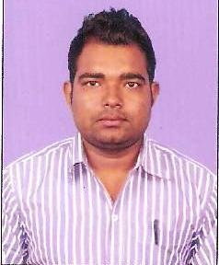

**Pradeep Kumar**

**Ratu Road Ranchi**

**P.o- Hehal, P.s- Sukhdeo Nagar**

**Dist- Ranchi (Jharkhand)**

**Pin Code-834001**

**Mobile No- 8603212530**

**E-mail Id-** [**pradeepcool.kumar66@gmail.com**](mailto:pradeepcool.kumar66@gmail.com)

**CAREER OBJECTIVE**

Is to be a part efficient group of professional where I can work for the growth of the company as well as my own individual growth.

**WORK EXPERIENCE**

➢ Three months of experience as a **Business Development Executive** at Axis Bank.

**OTHER QUALIFICATION**

* Diploma in Computer Application
* Tally

**ACADEMIC QUALIFICATION:**

|  |  |  |  |  |  |
| --- | --- | --- | --- | --- | --- |
| EXAM | UNIVERSITY / BOARD | SCHOOL/COLLEGE | P.YEAR | DIV | PER % |
| M.Com | R.U.Ranchi | Marwari College, Ranchi | 2013 | 1st | 64.25 % |
| B.Com (accounts Hons) | R.U.Ranchi | Marwari College, Ranchi | 2011 | 1st | 65.25 % |
| Intermediate (I.Com) | J.A.C, Ranchi | Marwari College, Ranchi | 2008 | 1st | 64.80 % |
| Matriculation | B S E B, Patna | R P C High School, Purnia | 2006 | 2nd | 57.10 % |

**PERSONAL PROFILES:**

 ➢       Father’s Name : Shankar Pd. Bhagat

 ➢       Date of Birth : 18th March,1991

 ➢       Nationality : Indian

 ➢  Gender : Male

 ➢       Marital Status : Unmarried

 ➢       Religion : Hindu

 ➢       Languages known : English, Hindi

 ➢  Hobbies : Playing Cricket, Do my work

Permanent Address : Vill-Khuski Bagh, Milan Para

P.o- Khuski Bagh

P.s- Purnia City

Dist- Purnia-854305 (Bihar)

**DECLEARTION**

I hereby affirm that the overview of my resume submitted to your office is true completed and correct to the best of my knowledge and belief.

**Date :**

**Place :              (Pradeep Kumar)**