* Personal C.V (Resume)
* Personal Datails - 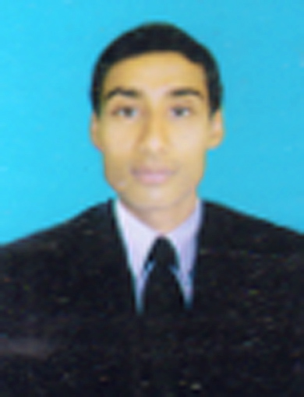

- Name – Prince Prithvi Raj

-Father ‘s – Ramadhar Sharma

-Village – Amarpura, Post – Alinagar Pali, P.S – Pali, Pin Code - 804418

-Dist – Jehanabad, State – Bihar

-Email Id – [mailprince25@gmail.com](mailto:mailprince25@gmail.com)

-Contact No - +919470474054, 9852785913

-DOB – 15/01/1995

- Languages known:- English ,Hindi

* Career objective –

-To work in a challenging environment using all my skills and efforts to explore in different fields and seek an opportunity for continuous learning

* Skill Sets –

-Good interpersonal skills  
 -Detail concious  
 -Confident  
 -Disciplined

* Technical SkillS –

- Installation and Configuration Desktop PC,OS Installation ,Formatting, Software Installation etc.

- Crimping Cables and Connectors. Managing workgroup and Domain Env

- Concept of OSI Layer and IP Addressing.

- Installation of Windows XP ,Windows 2007,2003 Servaer,2008 Server, Exchange Server 2003

- Knowledge of AD, DNS, DHCP,VPN,FTP,SMTP,NTFS,FAT32.

- Diskquota, Volume shadow copy ,RAID, Mounting etc.

- User account policy ,Group Policy and User profile management.

- File Folder Sharing ,Internet Sharing, Printer Sharing.

* Language -

-C, C++, JAVA   
 -HTML, CSS, JAVASCRIPT

* Operating Systems –

-Windows 7, Windows 8, windows 10

* Academic Projects –

1. Company Name - Wizard Tech Computer Academy (Pvt ).Ltd.

Project Name – DCA.

Study Center – Ambition Computer Center, Kako, Jehanabad ,(Bihar)With 76%

Duration – 6 Months From 04/08/2010 – 04/01/2011.

1. Company Name – Wizard Tech Computer Academy (Pvt).Ltd.

Project Name – CFA (Tally).

Study Center – Ambition Computer Center,Kako, Jehanabad, (Bihar)With 80%

Duration – 3 Months From June2013 – August 2013.

* Educational qualifications –

- Secondry – S A S High School Pali Bazar Kako (Jehanabad) With 58.6%

- Higher Secondry – I.Com From S N Sinha College Jehanabad (Bihar) With 48.6%

-Graduation – BCA From S N Sinha College Jehanabad (Bihar) With 67.12%

* ACHIEVEMENTS & PARTICIPATION -  
    
   -Participated in Technical fest of Graduation Collage.
* HOBBIES –  
    
   -Reading Books  
   -Internet Surfing  
   -Listening to music   
   - Playing cricket

Prince Prithvi Raj

Signature