**ARPIT GOEL**

**Specialization:**

Marketing Management

International Business

**Email:** arpitgoel456@gmail.com **Mobile:** 9582745673

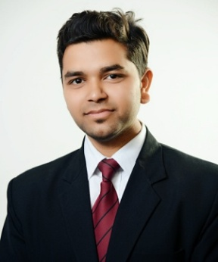

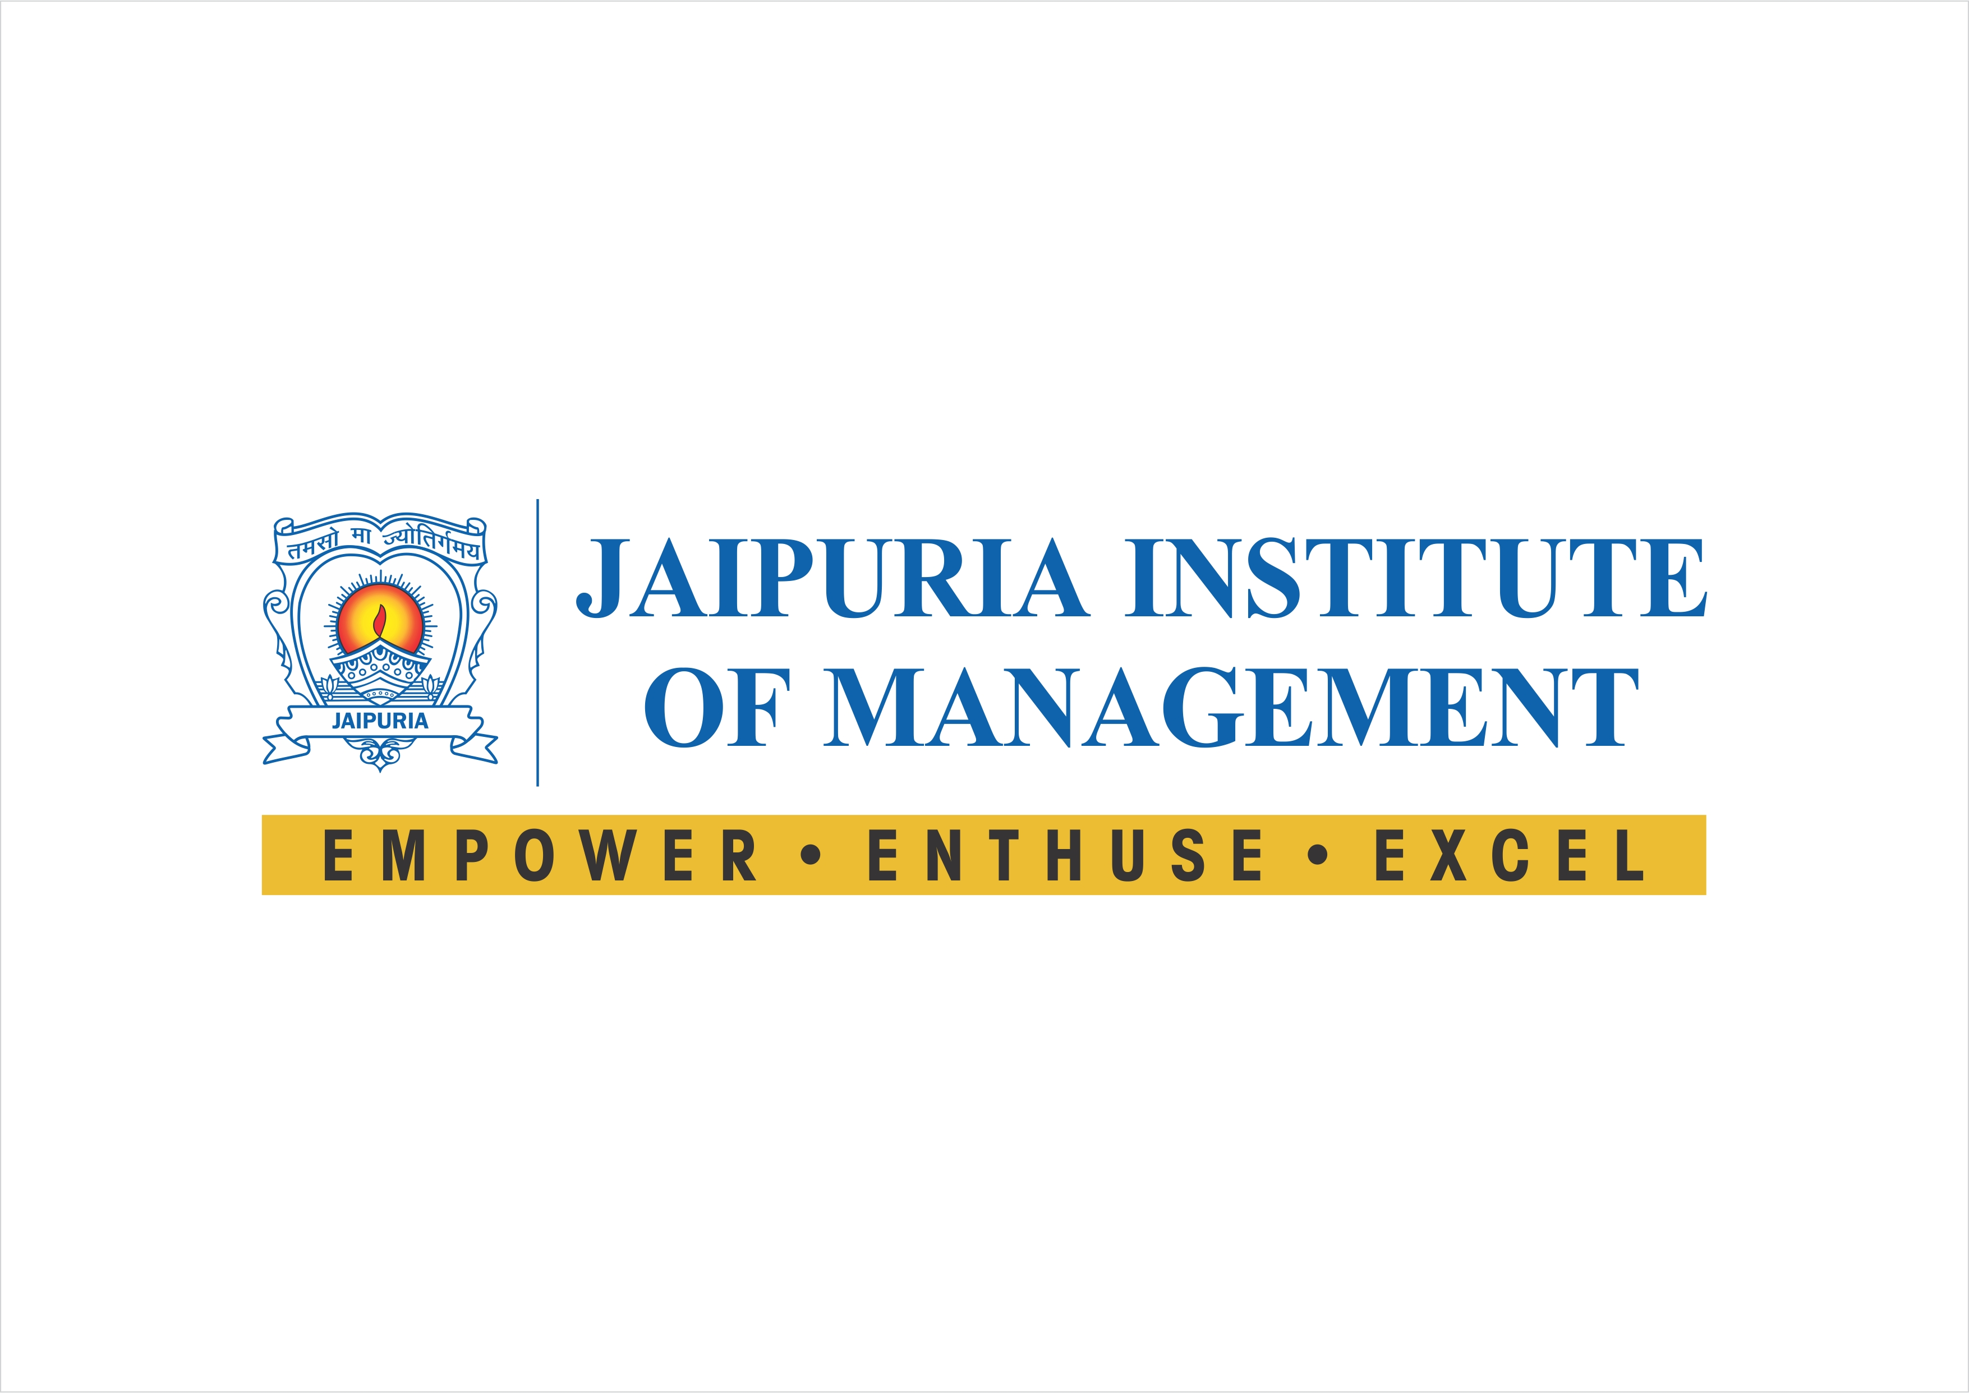

|  |
| --- |
| CAREER OBJECTIVE: |

To work with a prestigious organization that will provide me a platform to learn and gain new experiences. I will also offer my capabilities to the organization for its growth.

|  |
| --- |
| ACADEMIC QUALIFICATION: |

|  |  |  |  |
| --- | --- | --- | --- |
| Degree/ Certificate | Board/ University | Year of Passing | % of Marks/ CGPA |
| MBA | Dr. APJ Abdul Kalam Technical  University, Lucknow | 2018 | 68% |
| BHM | NCHMCT | 2015 | 64% |
| XII | UP BOARD | 2012 | 66% |
| X | UP BOARD | 2010 | 67% |

|  |
| --- |
| SUMMER INTERNSHIP PROJECT |

**Project Title**: Consumer buying behaviour towards Britannia products.

**Company Name**: **Britannia Industries Ltd.**

**Duration**: 60 Days

**Synopsis**: The project assigned was “**to identify the reason for consistent sales of title hearts”**.

Which includes the study of consumer behaviour and retailer survey in Delhi.

**SIP Project (At Graduation level)**

**Company Name**: **The Leela Ambience Convention Hotel, Delhi**

**Duration:**  17 Weeks

**Synopsis:** Worked in Kitchen, Bakery, Housekeeping and Banquets as an Intern.

|  |
| --- |
| EXPERIENCE |

I have worked in **Innolabz Ventures Pvt. Ltd.** as **Business Development Executive** for 6 months.

They are a leading name in the education enterprise owing to the spectrum of skills it offers for revamping the current arena of education vertical. They aim to bridge the persistent gap between the acquired knowledge and the real skills set that is actually required to achieve the best in ther area of interest.

**Job Responsibilities:**

* Meeting with clients
* Lead generation and bring business for the company

|  |
| --- |
| SKILLS AND PROFICIENCY |

IT PROFICIENCY

* Proficiency in MS Office

OTHER SKILLS

* Communication Skills
* Leadership Skills
* Problem analysis and solving skills
* Confidential responsibility

|  |
| --- |
| ACCOLADES/ACHIEVEMENTS |

* Participated in the **Corporate Summit on Talent Management: Building competency, capability and culture.**
* Participated in the **Satya Sai workshop** held at Jaipuria Institute of Management.
* Participated in the **Mercato** fest held in Jaipuria Institute of Management on 14th October’17.
* Industrial visit to **Amul** on 20th August,17
* Was awarded for hosting and managing an Event in Graduation.
* Participated in the **Amarujala with Gillette workshop** held at Jaipuria Institute of Management.

|  |
| --- |
| PERSONAL DETAILS |

* Date of Birth : 30th January 1996
* Languages known : English, Hindi
* Nationality : Indian

Signature:

Date: