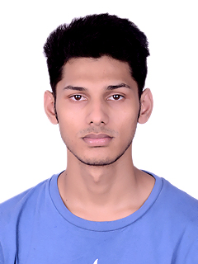

**RAHUL PANDEY**

**Mobile: +91 -9675739171**

**E- mail: rahulpandey094@gmail.com**

|  |
| --- |
| **CAREER OBJECTIVE** |

Intend to build a carrier with leading corporate of hi-tech environment with committed and dedicated people, which will help me to explore myself fully & realize my potential.

|  |
| --- |
| **ACADEMIC BACKGROUND** |

* 6 Months regular PG Diploma in Advanced Computing from CDAC(Center For Development Of Advanced

Computing) from Bangalore in 2015.

* Completed B.Tech in Information Technology from College Of Engineering Roorkee, Roorkee in 2014.
* Completed HSC from H.G.S.S.V.Mandir Inter College Haldwani Under U.A Board. (2010).
* Completed SSC from H.G.S.S.V.Mandir Inter College Haldwani under U.A Board. (2008).

|  |
| --- |
| **COMPUTER PROFICIENCY** |

* Programming Language: Java, C/C++ and Database Technology.

|  |
| --- |
| **ACADEMIC PROJECT** |

**PROJECT-**

**Duration** : 1 Month

**Title** : Personal Health Portal

**Platform** : J2EE

**Description** : We designed a website which takes care of all the health issues of the client who have registered on our Website. This project will take care of all the health issues of a person and his family in terms of vaccinations, regular health checkups, dental checkups etc by sending notifications regarding dates to his/her profile. As soon as the client confirms the date the required and decided action will be performed.

|  |
| --- |
| **CO-CURRICULAR ACTIVITIES** |

* Participated in college level fest.

**SKILLS**

* Analytical, logical and problem solving ability.

**HOBBIES**

* Travelling.
* Playing cricket.
* Playing Badminton.
* Bike riding.

|  |
| --- |
| **PERSONAL DETAILS** |

Date of Birth : 25-10-1993

Father’s Name : Mr. Dinesh Chandra Pandey

Category : General

Gender : Male

Nationality : India

Home Town : Haldwani (Uttarakhand)

Permanent Address : C.M.T Colony, Dahariya P.O-Manpur (west) Haldwani Distt- Nainital

Languages Known : Hindi, English

Permanent Phone No. : +91-9675739171

I declare that the details above are correct and true to the best of my knowledge.

**RAHUL PANDEY**