**CURRICULAM – VITAE**

**RAKESH YADAV** 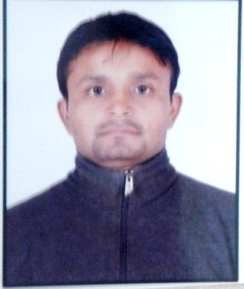

**Mobile: +91-9717807484**

**Email: rakesh.yadav.11987@gmail.com**

**CAREER OBJECTIVE**

Being a committed team player, want to be a part of a renowned organization, to contribute towards the growth of the Organization, based on my expertise and to further my personal capabilities by learning from the new exposure within the structured framework of the organization.

**EXPERTISE SUMMARY**

* Results oriented professional.
* Capable of taking initiative, highly approachable with the ability to work under pressure and be able to think and act strategically.
* Commendable organization, co-ordination and time management skills.
* Excellent comprehensibility, perfectionism, and open-mindedness to new ideas.
* Intelligent thinker, passionate and energetic.
* Good analytical skills, an in depth understanding of construction processes.

**ORGANISATIONAL EXPERIENCE**

* Worked with **Jet Airways** **Pvt. Ltd.** as an Store Coordinator. ( **2009 To 2011** )

(Maintain details of jet craft parts, Coordination with other staff)

* Worked with **Domino's** as Team Member. (**2011 To 2014**)

( Handling counter, worked with team member)

* Currently working with **Shri Sai Dwar Real Estate Consultant** as a Agent. ( **2014 Onwards** )

(Coordinate with clients and making calls)

**PROFESSIONAL QUALIFICATION**

* Basic Computer Application.

( Microsoft word, surfing on Internet)

ACADEMIC QUALIFICATION

* Graduate (B.A. Programme) from Allahabad University U.P in 2011.
* 12th Passed from Allahabad, U.P Board with Art Stream in 2008.
* 10th Passed from Allahabad, U.P Board From in 2006.

**PERSONAL INFORMATION**

|  |  |
| --- | --- |
| Father’s name | **:** Shayam Lal Yadav |
| Date of birth | **:** 11th Sep 1987 |
| Civil Status | **:** Male |
| Marital Status | **:** Married |
| Religion | **:** Hindu |
| Language Known | **:** English, Hindi |
| Nationality | **:** Indian |
| Address | **:** House No.D415, Gali No.59, Mahavir enclave,  New Delhi-110059 |

**Declaration**

I hereby declare that the above mentioned particulars are true and correct to the best of my knowledge and belief.

**DATE:** .............

**PLACE** .............

**(RAKESH YADAV)**