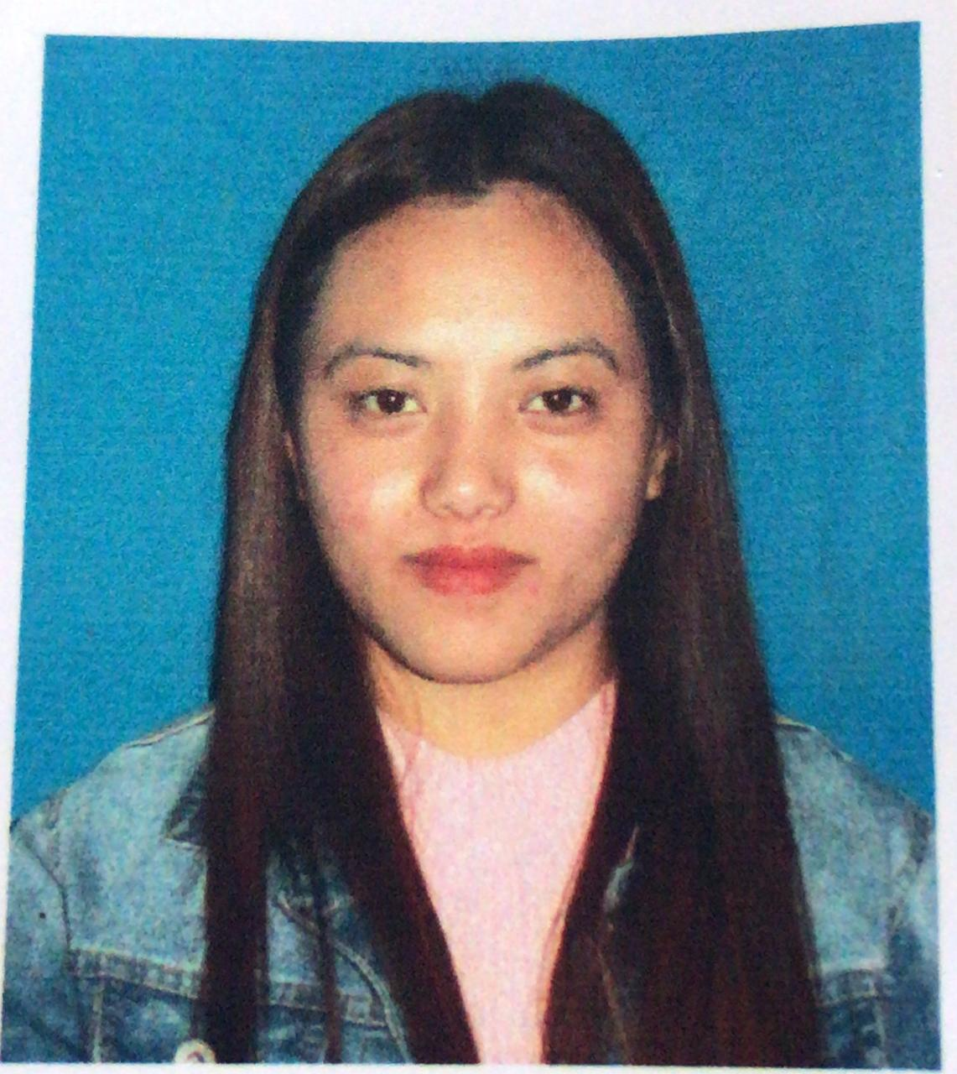

**PERSONAL DETAILS:**

**Name : Miss Chandra Maya Pradhan**

**Present Address : C/O Dr.L.P. Sharma Dhakal Gaun,Jalipool.**

**Post Office Ranipool, East Sikkim**

**Date Of Birth : July/20/1988**

**Religion : Hindu**

**Weight : 45 kg**

**Height : 5 feet**

**Languages Spoken : Hindi, English, Nepali**

**Phone number : 75017-48408**

**Email :** [**lp.sikkim@gmail.com**](mailto:lp.sikkim@gmail.com)

**EDUCATIONAL BACKGROUND:**

**Qualification: Class X Reading.**

**Occupation : unemployed**

**FAMILY DETAILS:**

**Name of Father : Krishna Kumar Pradhan**

**Name Of Mother : Sunita Pradhan**

**Permanent Address : Nechu 9th Mile PW Lingdok Nampong, GPU Lindok East Sikkim**

**SKILLS AND INTREST DETAILS:**

**Skills: responsible, motivated, energetic, caring, communication skills.**

**Hobbies: Listening music, playing indoor games reading, Social Work**

**­­­­**