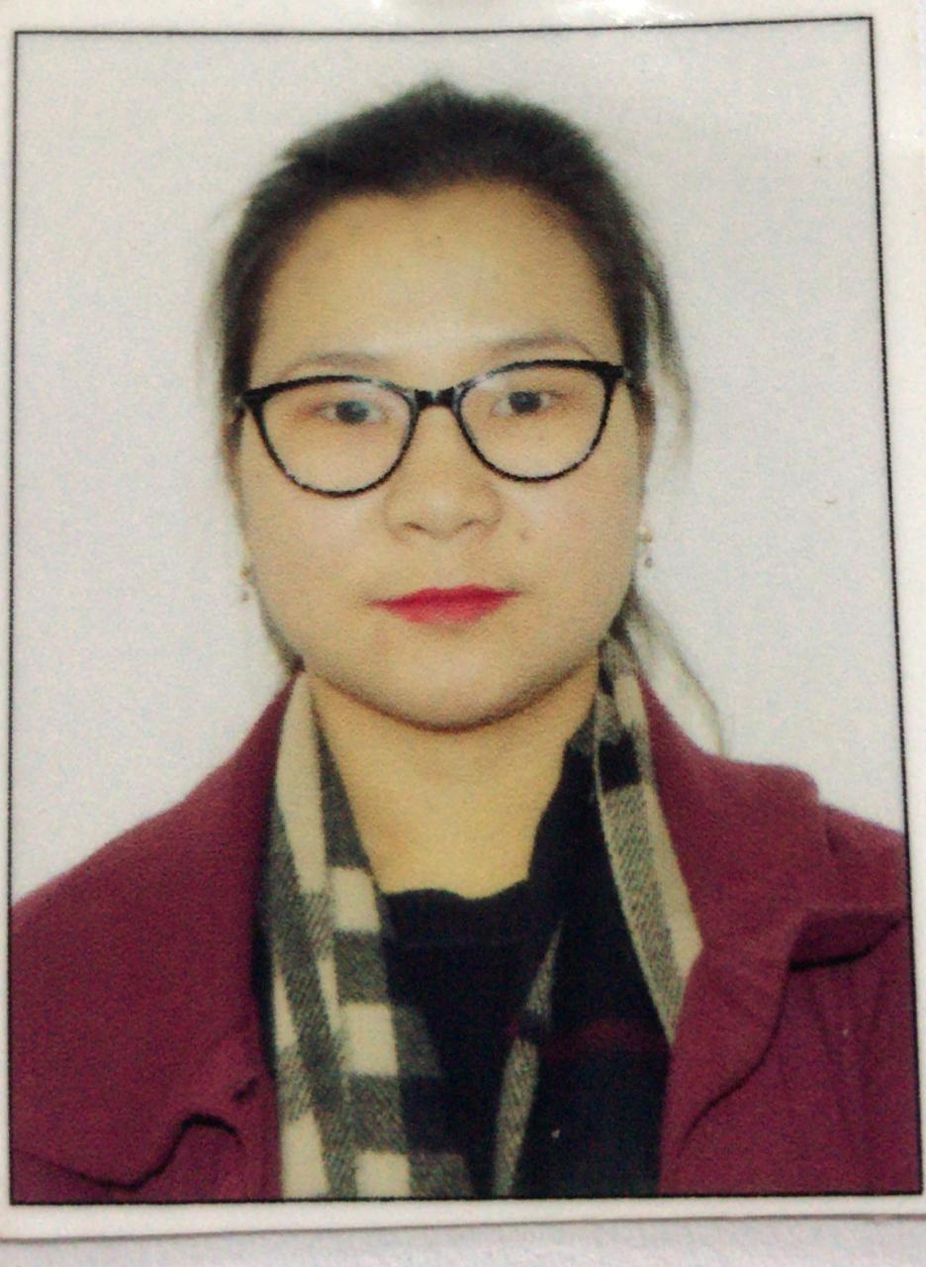

**PERSONAL DETAILS:**

**Name : Miss Anne Mery Tamang**

**Present Address : Lower Sichey, Gangtok, East Sikkim**

**Post Office Gangtok.**

**Date of Birth : 16/09/1991**

**Religion : Hindu**

**Weight : 50 kg**

**Height : 5 feet**

**Languages Spoken : Hindi, English, Nepali**

**Phone number : 8116566561**

**Email : enpark91@gmail.com**

**EDUCATIONAL BACKGROUND:**

**Qualification: class 8 pass**

**Experience : 8 years (in multi tasking work at NIC & SWAN Project Office)**

**FAMILY DETAILS:**

**Name of Father : James Tamang**

**Name Of Mother : Mariya Gorati Tamang**

**Permanent Address : Namcheybong, East Sikkim**

**SKILLS AND INTREST DETAILS:**

**Skills: responsible, motivated, energetic, caring, communication skills.**

**Hobbies: listening music, playing indoor games reading**

**­­­­**