**aSIT KUMAR TRIPATHY**

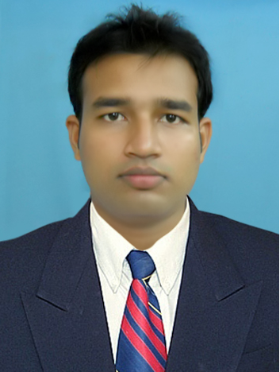

**POST APPLIED FOR – BUSINESS ANALYST**

B.Tech Electronics & Telecom. Engg. Phone: 09853810659

Ajay Binay Institute of Technology Email: asitkumartripathy89@gmail.com

CDA, Sector - 1

Cuttack - 753014, Odisha

**Objective**

To challenge the frontiers of my profession and perform at the highest achievable level and to work to the best of my potential and excellent skills and desire to become a successful technical diligent in the respective field.

**PROFESSIONAL EXPERIENCES**

|  |  |  |  |
| --- | --- | --- | --- |
| EMPLOYER | DESIGNATION | FROM DATE | TO DATE |
| Akanksha Power | Assistant Engineer | 3rd Oct. 2011 | Present |

* Having 2 Years Experience in field of APFC (Automatic Power Factor Correction System).
* I am now working in AKANKSHA POWER & INFRASTRUCTURE (P) Ltd from 3rd Oct. 2011 till now as an Assistant Engineer, which is an input based distribution franchise of NESCO for Khaira subdivision.

**EDUCATIONAL QUALIFICATIONS**

|  |  |  |  |  |
| --- | --- | --- | --- | --- |
| **DEGREE** | **INSTITUTION** | **BOARD / UNIVERSITY** | **YEAR OF PASSING** | **CGPA/PERCENT** |
| MBA | KCMR | PTU | CONTD. | 7.05 (UP TO 2ND SEM.) |
| B.Tech.  (ETC) | ABIT, Cuttack | BPUT,Rourkela | 2010 - 2011 | 6.58 / 61% |
| +2 (PCMB) | Christ College, Cuttack | CHSE, Odisha | 2006 | 47.33 |
| HSC | SBHS, Cuttack | B.S.E, Odisha | 2004 | 71.6 |

**Skill Set**

1. General dexterity **:** MS-Word, MS-excel, MS-Power Point

Windows 7, Internet.

**area of interest**

* Mobile communication technique
* IT Sectors
* VLSI
* Power Electronics

**PROJECT PROFILE**

**Project Name : INTRUDER WARNING SYSTEM IN FARM USING WIRELESS TECHNOLOGY.**

**Guide : Arnapurna Sahoo,** Lecture, Dept. of ENTC, ABIT, Cuttack.

**Duration :** December-April, 2010

**Description :** This project “**INTRUDER WARNING SYSTEM IN FARM USING WIRELESS TECHNOLOGY**” is an advanced methodology which can detect any human or animals entering into the farm and inform it to the landlord for necessary action.

**REFERENCES**

1. S.K.Mohapatra, Asst.Professor and Head

Electronics & Telecommunication Eng, ABIT, Cuttack

Mobile: 09861293505

**leadership & professional competencies**

* Innovativeness
* Analytical Thinking
* Work Arrangement
* Planning & Organizing
* Team Working

**PERSONAL pROFILE**

Name : Asit Kumar Tripathy

Date of Birth : 12/07/1989

Father’s Name : Purnendu Kumar Tripathy

Marital Status : Single

Nationality : Indian

Languages known : English, Hindi and Oriya

Address for Communication : C/O – Purnendu Kumar Tripathy,

AT-Budhimangala Vidyapitha, PataraSahi,

PO – College Square, Cuttack, Pin -753003, Odisha

Permanent Address : C/O- Purnendu Kumar Tripathy, AT-Ananda vihar, Aparna Nagar, Chauliaganj, PO-Nayabazar,

Cuttack, Pin-753004, Odisha

**DECLARATION**

Hereby, I assure that the information furnished above is true. If I get an opportunity to work in your concern, I assure that I shall discharge my duties to the fullest satisfaction of my Employer and to the best of my ability. Thanking you.

Asit Kumar Tripathy