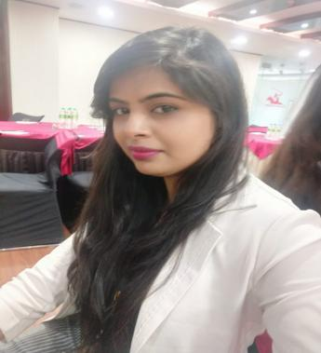

Contact

**Current Address:**

Vikas Enclave ,1st floor, Kardhani, Jaipur

**Phone:**

+91 8094132318

+91 8949033915

**Email:**

[sharma.sivika99@gmail.com](mailto:christoper.m@gmail.com)

**Dob :** 19th Jan 1993

Languages

Hindi & English

Hobbies

* Listening Music

Achievements & Activities

* Awarded as a Employee of the month in ACS CONSULTANT
* Participated in college cultural week as a Volunteer

Summary

HR Executive in IT & Non IT Recruitment . Experienced with all stages of the recruitment for IT & Non IT . Good understanding in team management and client relations. Also Good Experience in Sourcing & Screening Profile.

Skill Highlights

|  |  |
| --- | --- |
| * Performance Management * On boarding & Employee Engagement * Teamwork and collaboration | * Scheduling * Service-focused * Good Listener * Employee relations |

Experience

**HR Executive** -**1st May 2019 to 26th Aug 2020**

**ACS Consultant Pvt Ltd, Jaipur**

* Responsible for End –to- End recruitment of our clients for PAN India.
* Handled recruitment for various industries like BIG4, IT, FMCG, Paint Industry.
* Source Candidates through Candidate Application,Database, Linkedln ,other Job Portals (like: Naukri.com, Indeed,etc), Referrals, Internal & External Networking.
* Screening and shortlisting of profiles as per the client's

  requirements.

* Interview Candidate through assessment of candidate’s Experience ,Expectation,Suitability of role being put forward for (describing the work duties,Salary & Benefits of a Particular Vacancy).
* Negotiating on package with the shortlisted candidates.
* Maintaining a database of the candidates to cater the various recruitment needs of the client.
* Also a part of the internal hiring team to cater the in-house talent need of ACS.
* Simultaneously preparing and maintaining various MIS Reports like Tracker sheet, requirement and offer reports.

**Reason for Change : Due to the current Crisis I am not financially secure**

**Counsellor - 08/2018 to 04/2019**

**Turning Point Institute, Kota**

* Handling EIS Software
* Faculty Recruitment
* Handling Kota, Alwar & Solapur Branch
* Handling Students & Parents Counselling
* Data Maintain Online & Offline

**Reason for Left** : Institute wind up

**HR Recruiter** - **04/2017 to 07/2018**

**Spotlight Career Solutions Pvt Ltd,** Kota

* Responsible for End –to- End recruitment of our clients for PAN India.
* Campus Drive & Client Handling
* Employee Engagement, Development & HR Events
* Exit Formality & Interview

**Reason :** For Future Growth

**Education**

B.Tech: **Information Technology** - 2015 from RTU, Kota, Rajasthan

Shivalika Kothari