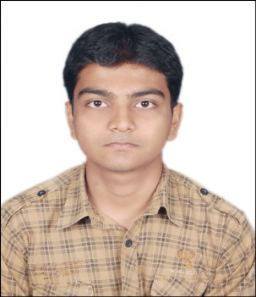

**ANURAG BAKSHI**

**S/o MITHILESH KUMAR,**

**HI-107, HARMU HOUSING COLONY,**

**RANCHI – 834002**

**MOBILE NO – 9905828929**

**Email –anuragbak@gmail.com**

**OBJECTIVES**

To obtain a responsible post with an opportunity for professional growth to support and enhance the objective of the company.

**ACADEMIC QUALIFICATION**

|  |  |  |  |
| --- | --- | --- | --- |
| **STANDARD** | **BOARD** | **SUBJECT** | **PERCENTAGE** |
| 10th  (2006) | CBSE | MATHEMATICS, SCIENCE, ENGLISH, SOCIAL STUDIES, SANSKRIT. | 73.6% |
| 12th  (2008) | CBSE | MATHEMATICS, ENGLISH, PHYSICS, CHEMISTRY, COMPUTER SCIENCE. | 55.6% |

**GRADUATION**

|  |  |  |  |  |
| --- | --- | --- | --- | --- |
| **COURSE** | **COLLEGE** | **UNIVERSITY** | **BRANCH** | **AGGREGATE** |
| B. Tech.  (2012) | R.V.S. College of Engineering & Technology | Ranchi University | Electronics  &  Communication | 66.4%  7.4(CGPA) |

**B. TECH.INDUSTRIAL TRAINING**

One month vocational training from **ARTTC, RANCHI.**

Training Period: 16/05/2011to 10/06/2011.

**B. TECH. FINAL YEAR PROJECT**

**TOPIC**

GSM Based Safety System

**DEFINATION**

This project dealt with the automatic sensing of smoke, fire and rise in temperature in the surroundings and sends an SMS to the predefined cell phone number saved in the memory in order to alert the owner that either of the hazards has been occurred.

**DESIGN**

1. **POWER SUPPLY CIRCUIT**

Transformer, Rectifier, Voltage Regulator (LM7805, LM7812).

1. **THE DETECTION CIRCUIT**

Microcontroller ATMEGA8, Voltage Divider, Sensor (LM35 Series Sensor), Diode, Switch, LDR, GSM Modem, LCD Display, SIM Card.

**FUTURE SCOPE**

It can be used to prevent accident and mass destruction in homes, malls, schools and can prevent loss of lives.

**PERSONAL PARTICULARS**

|  |  |  |
| --- | --- | --- |
| **Name** | : | AnuragBakshi |
| **Father’s Name** | : | Mithilesh Kumar |
| **Date of Birth** | : | 1st July, 1989 |
| **Nationality** | : | Indian |
| **Languages Known** | : | English& Hindi |
| **Gender** | : | Male |

**WORKING EXPERIENCE**

* Working as Software Developer in Uniworld Marketing India Pvt. Ltd.

From 10th of October 2012 to 11th June 2013.

**STRENGTHS**

Good communication and inter personal skills, smart worker, self confidence, keen sense of understanding the pulse of the public, ability to work in a group, and ability to be cool and calm in tough situation.

**TECHNICAL SKILLS**

* ASP.NET
* JAVA BASICS
* Microsoft Office

**HOBBIES**

Playing guitar, listening to music and reading novels.

**ACHIEVEMENTS**

* Participated in **“6TH NATIONAL SCIENCE OLYMPIAD”** in 2004 and got 89 All India Rank held in Ranchi.
* Qualified for 2nd round of**“6TH NATIONAL SCIENCE OLYMPIAD”** and secured 412 marks.
* Participated in **“4th NATIONAL CYBER OLYMPIAD”** and got 1528 All India Rank held in Ranchi.
* got certificate of participation in **“automatedROBOTICS”** organized by NIT Jamshedpur (09/03/2010 – 10/03/2010).
* Yellow Belt in **Indian Karate** under W.K.F. recognized by International Olympic Committee.

**DATE-** 05-07-2013

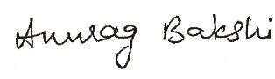

**PLACE-** Ranchi **ANURAG BAKSHI**