**RESUME**

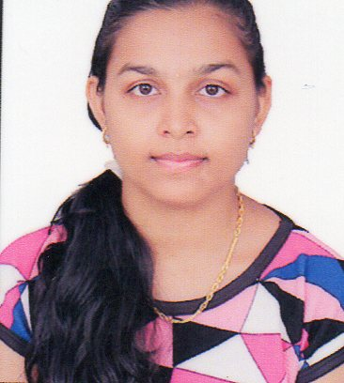

Minaxi Jaydeep Apandkar

E 303, Tirupati Appt.,

Khariwad, Nani Daman

Contact No**:** +919879778261

E-Mail**:**minaxiapandkar@gmail.com

**CARRER OBJECTIVE**

To work hard with full dedication for the achievement of organization objective under satisfying job contact, hence enhancing my skill and knowledge and ready to learn new things.

**EDUCATIONAL QUALIFICATION:**

|  |  |  |  |  |  |
| --- | --- | --- | --- | --- | --- |
| **SR. NO.** | **EXAMINATION** | **COLLEGE/SCHOOL** | **UNIVERSITY/BOARD** | **PERCENTAGE** | **YEAR** |
| 1 | Bachelors of Computer Application (B.C.A) | Shrinathji College of Computer Application, Daman | Veer Narmad South Gujarat University, Surat | 62.20 | 2018 |
| 2 | H.S.C. | Technical Training Institute, Daman | Gujarat Secondary & High Secondary Education Board, Gandhinagar | 56.05 | 2015 |
| 3 | S.S.C. | Government High School, Nani Daman | Gujarat Secondary & High Secondary Education Board, Gandhinagar | 46.5 | 2012 |

**EXPERIENCE:**

|  |  |  |  |  |
| --- | --- | --- | --- | --- |
| **SR. NO.** | **NAME OF ORGANIZATION** | **DESIGNATION** | **PERIOD OF SERVICE** | |
| **FROM** | **TO** |
| 1 | Ma Auto (Bike Showroom) | Data Entry Operator | 6 Months | |
| 2 | Aayushman Bharat | Data Entry Kit Operator | Till Date | |

**TECHNICAL SKILLS:**

|  |  |
| --- | --- |
| **Platform (OS)** | **:** Windows 2003 ,xp, Widows 7, Widows 10, Unix. |
| **Database Software** | **:** My SQL. |
| **Languages Known** | **:** Java, C, C++, |
| **Web technology**  **(Server side)** | **:** PHP, WordPress. |
| **Web technology**  **(Client side)** | **:** HTML, CSS, Dreamweaver, Java script. |

**ACADEMIC PROJECT:**

* **Title:** Project on “**My Daman”** at Daman in PHP.

**PERSONAL INFORMATION:**

* Name : Minaxi Jaydeep Apandkar
* Date of Birth : 28 December 1993
* Gender : Female
* Marital Status : Unmarried
* Languages Known : English, Hindi, Gujarati & Marathi.
* Nationality : Indian

**DECLARATION:**

I hereby declare that all statement made in this application from are true, Complete and Correct to the best of my knowledge and brief.

**Date –**

**Place-Daman**

**Signature**