**MD INSAN**

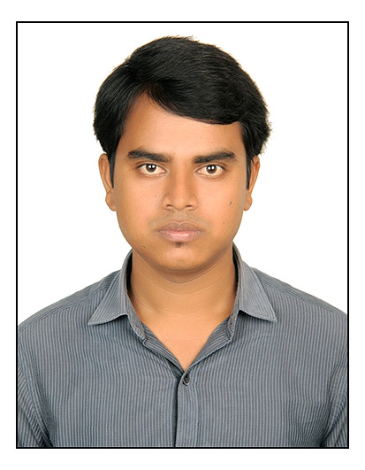

**Email:- insanmd24@gmail.com**

**Mob no:- +91-9022723672,8233216070**

**Address:- VNP Marg, Sharad Nagar, Chembur, Mumbai-400074**

**OBJECTIVE**

I am looking for a good position in the field of Information and Technology in a prestigious company where previous skills and capabilities can be put to efficient use. I possess effective organizational skills and the ability to supervise a team and develope the final output.

|  |
| --- |
| **EXPERIENCE DETAILS:-** |

**ORGANIZATIONAL EXPERIENCE:-**

1.COMPANY :- , Mumbai

PROJECT :- ICDS, Govt. Project, Chembur, Mumbai, India.

PERIOD :- 2nd -May-2017 to till date

POSITION HELD :- Block Co-ordinator(IT) .

* Supporting training of AWW and supervisors in Information and communication and enable Real Time Monitoring(ICT-RTM) of ICDS.
* Monitoring usage of ICT-RTM by AWWs by using CAS reports and follow up on low usage.
* Providing in-person and over phone troubleshooting support to users facing hardware and software problems Computer and peripheral devices basic issues with CAS application.
* Logging issues in the tracker application which is the part of CAS.
* Providing performance feedback to higher authority.
* Submitting devices to Original Equipment Manufacturer OEM for Hardware replacement and repair.
* Supporting block level to ICDS official on usage of CAS system.
* Escalation issue to Management by the issue tracker application.
* Timely submission the report to the Project Management.

2.COMPANY :- Impact Infotech,Thane, Mumbai

PROJECT :- Yes bank ltd, Elphinston road, Mumbai, India.

PERIOD :- 9th -March-2016 to 20th -Jan-2017

POSITION HELD :- Desktop Support Engineer.

**Desktop Experience:-**

* Remote-Assistance to Users computers.
* MS Outlook configuration and Troubleshooting.
* Basic IP Phone Support.
* Cisco Jabber installation and Troubleshooting.
* Basic Networking issues troubleshooting.
* Day to day troubleshooting on hardware and software.
* Network printer configuration by Remotely or visiting.
* Folders sharing and security permission.
* Unlock locked accounts, Reset User Passwords, Create Users, Disable Users, Rename Users on computers.
* Create/Remove PST by Remote for increasing mailboxes spaces.
* Installing, configuring, and troubleshooting on Microsoft Outlook Email Client.
* Troubleshooting of User problem related with laptop and Desktop.
* Installation of Network printer and scanner.
* Configuring the IP phone with help of Network Team.
* Configuring MS Outlook, Back up & restore Email, Account, and Address Book.
* Implementation and administration of DNS, DHCP.

**EDUCATION QUALIFICATION:**

|  |  |  |  |  |
| --- | --- | --- | --- | --- |
| **Class** | **Board/ University** | **Institute Name** | **Passing Year** | **%Marks** |
| **B. Tech. (Electronics &Instrumentation)** | Rajasthan Technical University  Kota | Compucom Institute of Information Technology & Management ,Jaipur | 2014 | **63.76%** |
| **XII th** | Bihar School Examination Board , Patna | Marwari Inter College, Katihar | 2009 | **67.44%** |
| **X th** | Bihar School Examination Board , Patna | Gandhi High School, Katihar | 2006 | **59.44%** |

**INDUSTRIAL AUTOMATION TRAINING:**

**Industrial Automation Training from Sofcon India Pvt. Ltd, Jaipur**

**Duration: - 3 months**

• SCADA: Wonder ware’s In touch, RS View, Application & Development.

• PLCs :( Allen Bradley, Modicon, Siemens & Mitsubishi)

Ladder & Logic Development Wiring & Trouble Shooting

• Process Instrumentation: RTDS, Thermocouples, Level Sensor, Flow sensor Inductive / capacitive Proximity Sensors (PNP or NPN Type), Photo electric sensors, Relays, Contactors, Thermal overload

• Communication with PLC using HMI.

**SUMMER TRAINING:-**  Indian Oil Refinery,Barauni.Bihar from 20th May 2013 to 16th July 2013.

|  |
| --- |
| **COMPUTER PROFICIENCY:** |

* **Certification** in Advance Diploma in Computer Application(ADCA) MS-Word, MS PowerPoint ,MS-Excel
* Data Communication Network knowledge like Network Topologies,Transfer Protocol,
* Operating Systems **-**Windows 8, Windows 7.

**PERSONAL DETAILS:**

* Date of Birth : 26th Jan 1991
* Father's Name : MD ALAM
* Permanent Address : Sharifgunj,PO-Daheria,Katihar (Bihar) India-854103
* Marital Status : Unmarried
* Language Known. : Hindi, English, Urdu
* Nationality : Indian
* Hobbies : Listening to music, Surfing Internet , Reading Newspaper.

**DECLARATION**

I hereby declare that all the information furnished above is correct and complete to the best of my knowledge and belief. if any given above is found false/incorrect, my candidature is liable to be rejected.

**Date:**

**Place: MD INSAN**