**CURRICULUM VITAE:**

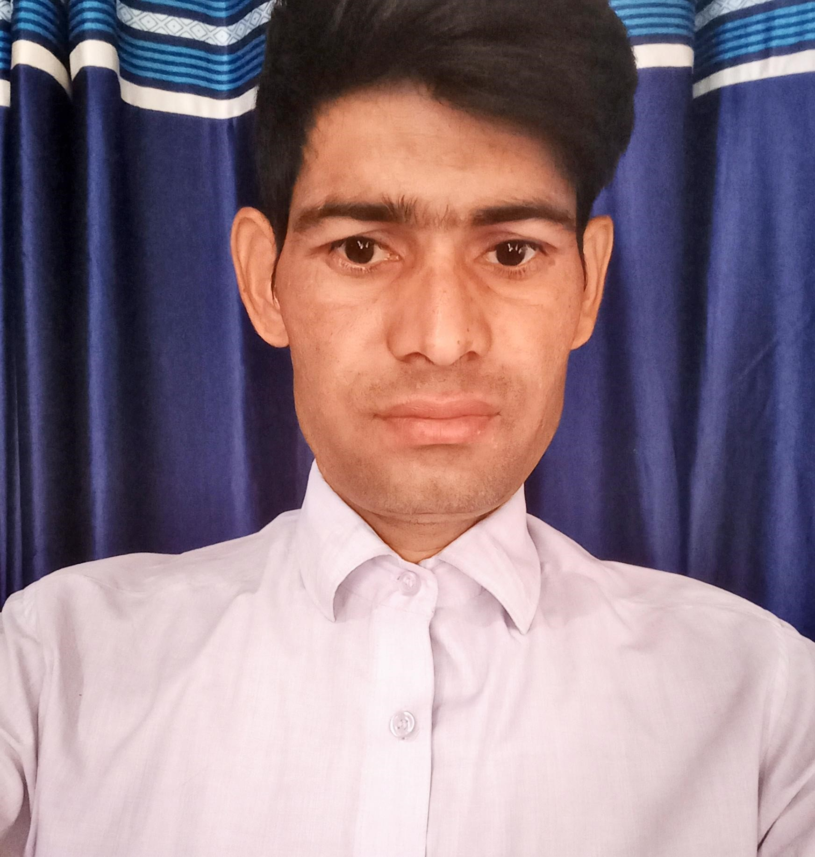

**KALURAM**

Vill.- Momanpur (Talwar)

Post – Jaguwas

Teh.- Behror

Distt.- Alwar (Rajasthan)- 301701

**Mob.- 9929793484, 8287280052**

**Email Id: kaluramyadav2304@gmail.com**

**Career Objective :-**

To work in an organization where I can grow my knowledge & prove my skills. To work in an organization where I can enhance in a free atmosphere.

**Educational Qualification:-**

* 10th Passed from Secondary Board of Education, Ajmer (Raj.).
* 12th Passed from Secondary Board of Education, Ajmer (Raj.).
* B.A Passed from Sunrise University, Alwar, Rajasthan.
* Three yearspolytechnic diploma passed from Board of technical education Rajasthan, Jodhpur
* Three months Auto Cad + Max diploma from Punia group of Education
* Knowledge about tally

**Professional Qualification:-**

* Six months Computer Diploma RS-CIT from VMOU Kota (Raj.)

**Computer Knowledge :-**

* MS-Office, SAP, AGES, E-Way Bill,

**Company Profile ;-**

* Caparo Maruti Ltd, Bawal, Haryana has gained immense expertise in supplying & trading of stampings, body parts, chassis parts etc.
* It caters to various small and mid-sized models of MSIL VIZ, ALTO, ZEN WAGNOR R, SWIFT, SX4 etc.
* Sogefi Engine System, Gurgaon Haryana has gained immense expertise in supplying & trading engine plastic body parts, & water pump for Tata Motors ford, MSIL, M & M, Honda and Hero Filter.

**Work Experience :-**

* One year work experience in caparo maruti ltd. Bawal, Haryana from March 2017 to February 2018 in PPC department .
* Three years and seven months work experience in Sogefi Engine System, Gurgaon Haryana from February 2018 to till date as a store / dispatch executive.

**Job Profile :-**

* To maintain shortage norms, inventory norms and location chat incoming & outgoing.
* Arrange material packing Depth. As per plan and details all moments child parts in company used assembly line.
* Reconciliation of material with physical bin card, system stock.
* To maintain our area 5’s incoming & outgoing location.
* Preparing invoices, Delivery challan, sales return documents.
* Knowledge uploading bin cards, maruti extranet, incoming parts tag and scanning etc.
* Maintain to make daily report all child parts and plastic granule is used molding.
* Make monthly report bin and trolly we used in dispatch parts and material moments parts.
* List of stock transfer sub units and incoming material.
* Upgrade daily report register for incoming & outgoing material.

**Language Known :-**

* Hindi & English

**Current Salary Package :-**

* Basic 14.5 K

**Strengths :-**

* Punctuality
* Positive attitude
* Self motivation
* Confidence

**Personal Details :-**

Father’s Name : Sh. Ramanand

Date of Birth : 03-06-1987

Gender : Male

Religion : Hindu

Marital Status : Married

**Declaration :-**

I hereby declare that all the information’s provided here are correct to the best of my knowledge.

**Date………………**

**Place……………..**

**(Kaluram)**