**RESUME**

**Prashant Kumar** 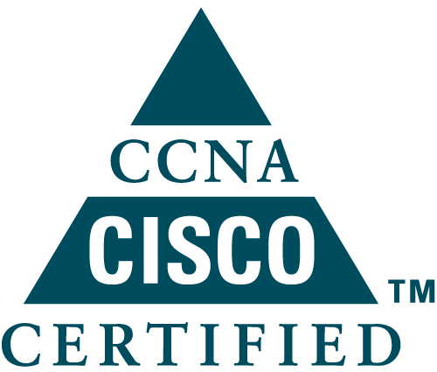

House No. 887, Ground Floor,

Sector – 5, Vasundhara

Ghaziabad

Uttar Pradesh

91 8882930309

[**praghav2212@gmail.com**](mailto:praghav2212@gmail.com)

Objective

Intend to build a carrier with leading corporate of hi-tech environment with dedicated people, which will help me to explore myself and realize my potential. Wish to work as key player in challenging & creative environment.

Educational Qualifications

## Professional Qualification

## B. Tech. in Electronic & Communication from Uttar Pradesh Technical University, Lucknow (U.P.) in 2011 with First Division.

Work Experience

1. **Current organization:** Team Computers Private Limited

**Designation:** Network and Security Engineer

**Duration:** 1 August 2013 to till date.

**Roles and Responsibilities** –

1. Providing Technical Network Security Presales Support to Customers as well as internal Sales Team
2. Understanding the client's business requirements, technical requirements and/or competitive landscape
3. Solution Presentations, Demonstrations and Proof of concept setup deployment.
4. Hands on Experience in security like Cyberoam/Sophos, Fortigate , Cisco ASA.
5. Looking after all Internal Network as well as spoke sites across all India.
6. Managing Cisco Switches and HP Switches (Cisco 2950, 2960 & 3750x, 4500x, 9300, 9500) and Routers (Cisco1841, 1921) including configuration and up-gradation and VLAN Management.
7. Level 3 Technical support, through incident management hierarchy, request queues and escalation
8. Hands on experience in Wireless like Aruba & Cisco.

Technical Expertise

1. **Installation and Configuration of Cisco/HP Routers:** Mounting Router, Basic configurations (Interface IP, Static Routing, Console Management, upgrading IOS), VRF Configuration, HSRP Configuration, VRRP Configuration and GLBP Configuration.
2. **Installation and Configuration of Cisco/HP Switch (L2 and L3) :**Mounting Network Switch, Basic Configuration (Vlan, VTP, STP , Management IP, Console Configuration, switch port, Routing, Trunking), Software upgrade, SNMP and monitoring data mapping , Switch port mapping and mac binding, port spanning, cisco 4500, 6500 and 9500 chassis installation and configuration, cisco 3750/3650 fabric switch installation and configuration, HP 5400 Series switch installation and configuration, san switch deployment with initial configuration, san switch – zone creation, san switch configuration in HA. VSS Configuration, 802.1x configuration and Port Security.
3. **Configuration of Aruba IAP and Cisco AP:** Controller (Basic Configuration), Authentication (Local/LDAP/Radius/AD), and AP Authentication (Local/LDAP/Radius/AD), AP Configuration.
4. **Installation and Configuration of Firewall (Cyberoam, Fortigate and ASA):** Configuring the UTM in gateway mode / Transparent mode , user identity – based security policy controls/web filtering , Access control and Zone configurations along with NAT/PAT , Configuring VPN – peer to peer , firmware upgrade , Bandwidth management, licence activation and certificate installation , Application Link Management , Active – Active High Availability , Outbound Spam Protection , Layer 8 identity based policy, load Balancing.

**Specialization**:

**CCNA: – Routing & Switching (License No-** **CSCO13456803)**

**CCNA: - Security (License No-** **CSCO13456803)**

**Sophos:- Sophos Certified Engineer**

**Sophos:- Sophos Certified Architect**

* Cisco 2900, 4300 Series Routers (2921, 4300).
* Cisco 2900 Series Switches(Cisco 2950 ,Cisco 2960)
* Cisco 3750x L3 switch with Stacking, VLAN, STP, RSTP
* Cisco 3850 L3 switch with stacking
* Cisco 4500 Series Switches
* HP A5500 L3 Switch
* HP 5400 Chassis Switch
* HP/Aruba L2 Switch (1920, 2530, 2540,2930)
* Nexus 9K
* Cisco ASA 5505, 5506X, 5508X, 5510X,5512X.5515X AND 5516X
* Cyberoam 25ing, 50ing, 100ing and 200ing
* Sophos 125xg, 210XG, 400XG
* SonicWALL TZ300 with IPSEC VPN and Natting.
* Fortinet 100D, 100E, 200E and 300E.
* Application Protocols DNS, DHCP, SMTP, TELNET, FTP, HTTP.
* Sophos Endpoint Installation & Configuration.

**Project Undertaken**

**Project Name**

1. **Centre For Department of Telematics – Data Centre Configuration.**
2. **ITC Limited :- Network Implementation .**
3. **Tikona:- Installation and Configurations of Routers.**
4. **Perto India Pvt Ltd - Network implementation .**
5. **North East Nutrients Private Limited – Network Implementation.**
6. **Aditya Birla Skills Foundations – Network Implementation and Security Implementation.**
7. **BMW India Pvt Limited – Network Implementation**
8. **Orissa Cement Limited – Network Implementation.**
9. **Pathkind Labs – Network and Security Implementation.**
10. **NBCC India Limited – Security Implementation.**
11. **Dalmia cement India Limited – Network & Security Implementation.**
12. **Mitsubishi Electric Automative India Private Limited – Network & Security Implementation.**

Co-Curricular Activities

* Attended training program on “Technical concepts of computer languages”organizedby **CETPA INFOTECHPvt.Ltd.,Noida.**
* Attended “ **Huawei Routing and Switching”** at Huawei, Gurgaon.
* Attended **“Internatinalconference on Neno-Bio technology”**organized by SIEM, Mathuraon 15th JAN 2009
* Summer Vocational Traning in Bharat Electronic Limited, Gaziabad.
* Presentation on “Radar” at college level.
* Attended **“2nd National conferenceon Recent Advance of Solid State Materials And Devices”**organized by SIEMon 2nd NOV 2010

**Personal Details :**

Father name: Surendra Pal Singh

Date of Birth: 22 Dec, 1988

Sex : Male

Nationality : Indian

Marital Status: Single

Languages Known : English & Hindi

*Hobbies:* Cricket, Listening, music and internet surfing

Declaration

I am a person with interpersonal skills and great ability to work in a team with diverse backgrounds. Moreover, I have strong commitment to quality, dedication, determination and discipline, willing to learn and adapt to new opportunities and challenges.

I hereby declare that the information given above is true to the best of my knowledge.

**Prashant Kumar**

**DATE**: **PLACE:**