**Abhishek Sharma**

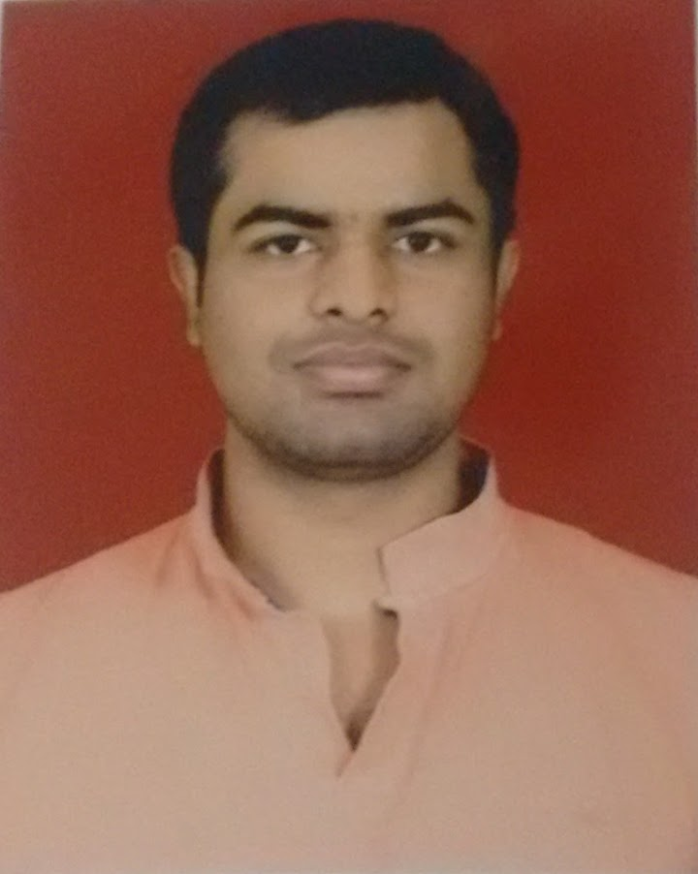

Mobile: +91-8447778082  
E-mail: abhi301912@gmail.com

**Career Objective**

Seeing a career as a Website developer in a progressive website development company and to effectively utilize the knowledge gained in my academic curriculum & from life for attaining a responsible, challenging and rewarding position.

**Technical Skill Set**

**Languages/Technologies:** JAVA, JavaScript, SQL, HTML, Bootstrap, css.  
**Database:** MySQL, Oracle  
**Distributed/Web Environments:** Apache Tomcat 8.0.9  
**Development tools:** NetBeans IDE 8.0.1  
**Operating Systems:** Windows 7/8.1/10

**Functional Skills Set**

* Ability to handle a team of developers and co-ordinate smooth delivery of the project.
* Training the new members in the team and getting them productive quickly.
* Strong client facing skills.
* Problem solving capability peered with strong communication skills.

**Key Project Undertaken**

**Project:** Shopping Store   
**Duration:** 2 months.  
**Environment:** Java, NetBeans 8.0.1 with Apache Tomcat 8.0.9, MySQL, Css , Bootstrap  
**Project Detail:** I made a website of Shopping Store. The feature includes:

**User part:**  – Here user can view the products, choose different products

and login to the website by registration.

**Admin part:** – Here admin can add, delete, update the products, and manage the order.

**Responsibilities:**

* Interacting with the client to understand the project and finalize its scope.
* Mentoring junior members in the team.
* Coordinating with other teams working on the same project.
* Ensuring smooth delivery of the project.

**Academia**

|  |  |  |
| --- | --- | --- |
| **Exam** | **Year of Passing** | **University/Board** |
| **Bachelor of Commerce** | 2015 | University Of Delhi |
| **12th** | 2012 | C.B.S.E |
| **10th** | 2009 | C.B.S.E |

**Professional** **Qualification**

* Completed computer operator and programing assistance from BSAITM
* Completed **RGNIIT** from NIIT

**Personal Strengths**

* Positive Attitude,
* Good Communication Skill
* Leadership Skill
* Team Work Skill
* Effective Time Management

**Personal Details**

**DOB:** 30TH AUG, 1994.

**Marital Status:** Unmarried

**Languages known:** English, Hindi

**Address:** WZ-35C POSSANGIPUR,

JANAKPURI,

New Delhi - 110058

**Hobbies:** Watching Movies and Playing Games