**SUNIL KUMAR**

**Phone: +91-9910230396**

**E-mail: sksunilsharma77@gmail.com**

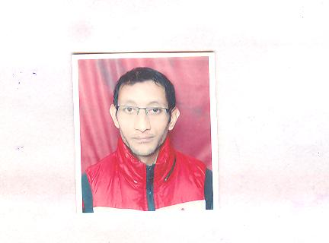

A competent professional targeting assignment in **General Accounting**, **Stock Handling** with a reputed organisation.

**PROFILE SUMMARY**

* **3 Years & 11 Months** experience in **General Accounting, Stock Handling, Purchase & Sale Bills Generating, Purchase Bills DS2 Filling.**
* Worked with **Handicrafts** **Private Limited** since **July 2013** to **June 2017** at **Jor Bagh Market, New Delhi** as **Account Assistant.**
* Knowledge of General Accounting.
* Knowledge of GST.
* Knowledge of stock handling.
* Skilled in purchase and sale bills generating.
* Knowledge of MS Office 2013 (MS Word, MS Excel Vlookup, Hlookup, Pivot Table, Power Point, Advanced Excel).
* Sound working knowledge of working on Tally 9 (ERP).
* A team player with excellent communication, coordination and problem-solving skills.

**ORGANISATIONAL EXPERIENCE**

Since **July 2013** to **June 2017: M/s Handicrafts Private Limited,** Jor Bagh Market, New Delhias an **Accounts Assistant.**

**CORE COMPETENCIES**

**~ General Accounting ~ Stock Handling ~ Data Entry**

**~ Accounts Receivable / Payable ~ Documentation ~ Invoice Processing**

**~ Internet Surfing ~ Bank Reconciliation ~ DS2 Filing**

**Key Result Areas:**

* Maintaining accounts; creating, documentation and posting journal entries; recording various intercompany transactions.
* Booking of receipts entries on daily basis.
* Booking of Expenses.
* Recording details for inter branch funds transfer.
* Creating & raising invoices for sales, purchase & support and maintaining hard copy of service agreements.
* Keeping the record of stock on excel sheet on daily basis.
* Supporting internal and statutory audits by providing information and answers to Auditors; following up for acquiring customer balance confirmation as per audit requirement.

**Highlights:**

* Recorded all accounting entries in ERP Microsoft Navision.

**PREVIOUS ORGANISATIONAL EXPERIENCE**

**March 2008- June 2008: M/s Airtel Private Limited,** Chandigarh as **Customer Care Executive.**

**CORE COMPETENCIES**

**~ Customer Care Executive (Inbound Process)**

**ACADEMIC DETAILS**

2013MBA (Finance & HR) from Himachal Pradesh Technical University, Hamirpur.

2010 B.Ed. from Himachal Pradesh University, Shimla.

2008 Graduation from Himachal Pradesh University, Shimla.

2005 10+2 from Himachal Pradesh Board of School Education, Dharamshala.

**PROFESSIONAL QUALIFICATION**

20171 Year Certified Industrial Accountant (CIA) Course from The Institute of Computer Accountants (ICA) at Chhattarpur, New Delhi.

20081 Year Complete Business Accountant (CBA) Course from Indian Institute of Job

Oriented Training (IIJT) at Sec. 34, Chandigarh.

**IT SKILLS**

* Knowledge of Tally 9 (ERP), GST, MS Office 2003/ 2007/ 2008/ 2010/ 2013 and Internet Surfing.

**PERSONAL DETAILS**

Father’s Name Shri Brahm Dutt

Mother’s Name Smt. Pawna Devi

Sex Male

Date of Birth 13th November 1985.

Marital Status Unmarried

Nationality Indian

Passport Yes

Languages Known English and Hindi

Permanent Address V. P.O. Kharat, Teh Baroh, Distt. Kangra, Himachal Pradesh-176054

Correspondence Address Sharma Farm Chhattarpur, New Delhi-110074.

|  |
| --- |
| **D E C L A R A T I O N** |

I hereby declare that the above written particulars are true to the best of my knowledge and confidence.

Date:

Place : Signature (Sunil Kumar )