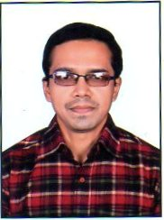 **VIKASH KUMAR SINHA**

**Address:** M.I.G. -28, Hanuman Nagar,

Kankarbagh, Patna-800020.

**Email:** vikgeo1992@outlook.com

**Mobile No.:**+91-9576966841, 7903873214

**CAREER OBJECTIVE**

* To become a successful and hardworking person in my life with sincerity in my work.
* To secure a challenging position in a company where I can enhance my skills.
* A self-motivated, initiative taker with good communication and soft skills.

**EDUCATIONAL QUALIFICATION**

|  |  |  |  |  |
| --- | --- | --- | --- | --- |
| **Exam passed** | **School/College** | **Board/University** | **Year of Passing** | **Percentage** |
| M.Sc. | Dept. of Geology | Patna University | 2015 | 66.44% |
| B.Sc. | Patna Science College | Patna University | 2013 | 64.62% |
| HSC | College of Commerce | BSEB (Bihar Board) | 2010 | 71% |
| SSC | B.D. Public School | CBSE | 2008 | 64% |

**PROFESSIONAL QUALIFICATION**

Diploma in Financial Accounting and Taxation with GST

**SKILL CERTIFICATION COURSE**

BS CIT (Information Technology), Communication skill and Soft skill from NIELIT, Patna

**TRAINING/FIELD WORK/WORKSHOP**

* Summer Industrial Training at **ONGC (Frontier Basin), Dehradun**
* Field work in **Bhojpur District, Bihar**
* Attended workshop conducted by **Central Ground Water Board** in **Patna**

**SKILLS**

* MS-OFFICE
* TALLY ERP 9 & GST
* ENGLISH TYPING (40 wpm) AND HINDI TYPING (35 wpm)

**WORKING EXPERIENCE**

* **1** year **10** months of working experience as an **Office Assistant** at Bhushan International.
* **9** months of working experience at Shakti Infotech Pvt. Ltd. as **MIS** in(DDU-GKY) and

**Technical Support** in **Tally Accounting Software**.

* Good knowledge of working at **MRIGS** and **MPR** Portal.

**PERSONAL TRAITS**

**STRENGTH**

* Confidence
* Positive attitude and Energy
* Adaptable to new environment
* Able to present myself in front of a people

**HOBBIES**

* Internet Browsing
* Teaching
* Listening to motivational quotes spoken by great personalities and Lords
* Interested in learning new features and settings of Laptops and Smart phones

**PERSONAL DETAILS**

Father’s Name- VIJAY KUMAR SINHA

Occupation- Clerk

DOB- 19-04-1992

Gender- Male

Nationality- Indian

Language- English and Hindi

**DECLARATION**

I hereby declare that the above-mentioned information is true to the best of my knowledge.

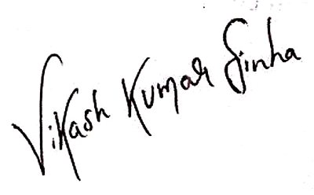**Place– Patna**

**Date-**

**Signature**