RESUME

|  |
| --- |
|  |

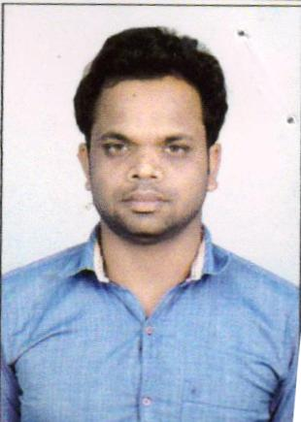

ASHOK KUMAR THAKUR Address: Vill-Rangritad, PO+PS-Topchanchi Distt-Dhanbad, State-Jharkhand. India Pin code-828402

Email:ashok809207@gmail.com

Contact No.: +917089618589, +918873322420

Objective:

To work with an organization that can utilize my skills in a right and proper way by which I can become a part of its, maintenance , give me responsibilities & challenges with an opportunity to grow.

**Educational Qualification:**

* 10th Passed From JAC RANCHI in 2005.
* 12th (science) Passed From JAC RANCHI 2009.

**Other Qualification:**

ENGLISH TYPING : 55 WPM

HINDI TYPING : 35 WPM

DCA

**Experience Details:-**

* 5 Year Experience in **IRCON INTERNATIONAL LIMITED** (PRADHAN MANTRI GRAM SADAK YOJANA) From 26/11/2012 to 01/03/2017.
* Presently Working Under **IRCON INTERNATIONAL LIMITED**(KATNI TO SINGRAULI DOUBLING PROJECT) From 02/03/2017 to till date.

**Personal Profile:**

Date of Birth : 01/01/1989

Father’s Name : Mr. Biru Thakur

Sex : Male

Category : OBC

Religion : Hindu

Languages Known : Hindi & English.

Nationality : Indian

Marital Status : Married

**Declaration:**

I hereby declare that the above-mentioned information is true to the best of my knowledge and belief that this curriculum-vitae correctly describes my qualification, experience and myself. **Date:-…../…../…….. (ASHOK KUMAR THAUR) Place:-**