**RESUME**

*NARAYAN RAWANI*

Mob . NO. 09835742117 & 8092680805

Email id : narayanrawani555@gmail.com

**OBJECT**

Looking for an environment where I could contribute an achievement of organizational goal with the organization.

**PERSONAL PARTICULARS**

Father’s name : Rathu Rawani

Mother’s name : Smt Purnima Devi

**Permanent address**

Vill : Parasbania (Orbhitha)

Po : Khasjeenagorah

Dist : Dhanbad (Jharkhand)

Pin. : 828115

**POSTAL ADDRESS** - : Do :--

Nationality Indian

Date of birth 2nd February 1986

Marital status Unmarried

Language known HIndi , English , Bengoli

**Educational Qualification**

1.MATRIC : J.S.E.B Ranchi 2nd division (53.40%) 2001

2.I.COM : J.I.E.C Ranchi 2nddivision (58.67%) 2003

3.B.COM : B.V.U Hazaribag 1st Division (62%) 2007

**TECHNICAL BACKGROUND**

1.Computer Knowledge : Advance Diploma in Computer Application

2.Knowledge of typing : Hindi 30 WPM and English : 35 WPM

3.One Year Working experience as a COMPUTER OPERATER IN KOLKATA WEAR

INDUSTRIE LIMITED

4. 2 Year Working Exprience as a COMPUTER Operator In SAIBABA INFRACON(P) Ltd.

5. Accounting Package : Tally Erp 9.1

**DECLARATION**

*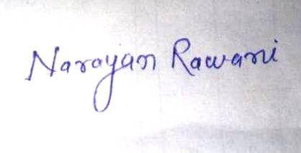I hereby declare that all the statements are true and correct to the best of my knowledge.*

Date :- 13.05.2017

Place:- Sindri *SIGNATURE*