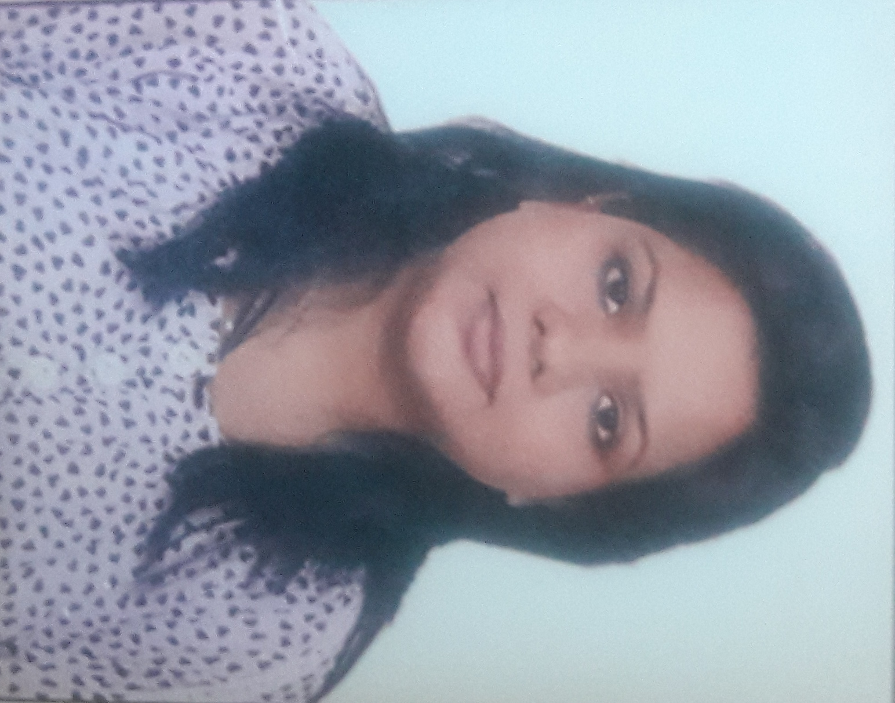

**Neeti George**

**20/144, DDA Flats, South Enclave, Ambedkar Nagar, New Delhi- 110062**

**Mobile: +91-9811725331; E-mail:** [**neeti.george@gmail.com**](mailto:neeti.george@gmail.com)

***Introduction***

A well presented, articulate and social young graduate of arts skilled in administrative duties and fully IT literate with sound academic & professional records. Highly observant and analytical, hard working and always a asset to a company.

***Core Competencies***

* Good at decimating knowledge down the line.
* Excellent customer service skills with a pleasant phone voice.
* Experience with all clerical functions
* Knowledge of computers.
* Team Player.

***Summary of Work Experience***

**VIPIN AGARWAL & ASSOCIATES.**

**Front Desk Executive *(19th July 2010 to till date)***

***Key Responsibilities:***

* To manage the front office operations providing support to sales professionals & customer service to clients and candidates.
* To assist and typically reports to the office administrator.
* To oversees the greeting and directing of all visitors, including vendors, clients, job seekers and customers
* To ensures completion of paper work, sign-in, and security procedure.
* To manages incoming phone calls using multi line phone system.
* To resolves customer questions and concerns coordinates meetings.

**AC BAKSHI & COMPANY Pvt. Ltd.**

**Team Manager *(4th Feb 2007 to 5th June 2010)***

***Key Responsibilities:***

* To motivate the telesales.
* To keep an eye on every field executive.
* To maintain files, to check report & to handle quarries.
* Maintaining MIS, & to see approval on every deviation.

**SHELTERS (Marketing Group)*Customer Care Executive (July 2006 to Feb 2007)***

***Key Responsibilities:***

* To make sales calls.
* To keep an eye on every sales lead.
* To maintain files, to check report & to handle quarries.
* To give support to team in absence of supervisor.

**Academics**

* B.A. from Delhi University, New Delhi.
* Intermediate from M. P. Board, Madhya Pradesh.
* High School from NOS
* Computer knowledge.

**Technical Knowledge & Skills**

* Diploma in Basics of Computers from RGSMCE, New Delhi.
* Proficient in using PCs and applications, including MS Office, Internet, Mails, etc.
* Demonstrated ability to quickly learn and apply new technologies effectively.

**Personal Details**

Date of birth : 20 May 1983

Languages known : Hindi, English.

Religion : Christian

Nationality : Indian

Sex : Female

Marital Status : Single

Soft Skills : Good Memory, Good correspondence skills, Team player.

Current Location : New Delhi, India

Hobbies : Reading Books, Cooking and Listening Music.

**Current CTC (INR) 2,40,000 P.A.**