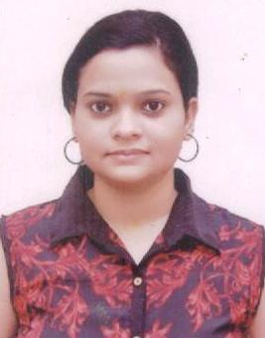 **REENA SHUKLA** A-26, Ram Nagar, Om Vihar,

Uttam Nagar, New Delhi-110059

E-Mail : reenashukla96@gmail.com

Mob : 8447300986/9211236272

**OBJECTIVE**

Hardworking, responsible and punctual professional seeking for an opportunity to pursue a career where knowledge and skill can be optimally utilized both for the company and for self-growth.

**EXPERIENCE**

**Office Assistant, Indian Council of World Affairs (ICWA) Sapru House (Working)**

* To look after all the administrative work, Liaison & establishment work,
* Booking the Air Tickets for the Senior Authorities,
* To maintain leave record of regular as well as contractual employees including maintaining their personal files and service books,
* Filing and keeping all files records,
* Making arrangements of seminar’s, calling and fixing the schedules for the programs,
* Responding to incoming and outgoing calls,
* Receiving and sending daily couriers,
* Drafting, sending and checking daily mails,
* Cashbook entry and handling challan book,

**Back Office Assistant in IDBI Bank. (1 year and 9 months)**

* Coordinating with the Saving Accounts team.
* Opening Saving Accounts.
* Money Transferring in Saving Accounts.

**Office Co-ordinator in Transport Dept. HSRP ( 1 year)**

* Coordinating with Customers.
* Public Dealing.
* Receiving and Replying day to day notes mails.
* Managing all Data in Excel files.
* Putting all details of clients into Software.
* Maintaining Attendance and leave Records.

**Additional Data Entry Operator at Election Office Vikaspuri. (1 Year)**

* Making Voter ID Cards.
* Maintaining all Voter's files.
* Public Dealing.
* Checking all documents of voters.

**Office Asst. cum Computer Operator at SDM Office. (1 Year)**

* Making Caste/ Death/ Birth/ Handicap Certificates
* Public Dealing.
* Managing all data and files.
* Posting all certificates by speed post and maintaining all record.
* Coordinating with Magistrate (Tehsildar).

**EDUCATION**

|  |  |  |  |
| --- | --- | --- | --- |
| **Examination**  **passed** | **Board/**  **University.** | **Year of**  **passing** | **Division with% of Marks** |
| PG (M.A) | IGNOU | 2016 | 50.33% |
| Grad (B.A) | Delhi University | 2013 | 44.17% |
| XII | NIOS | 2010 | 52.20% |
| X | NIOS | 2008 | 50.60% |

**ADDITIONALQUALIFICATION**

* One Year Diploma in Computer from Oxford Software Institute.
* Computer Fundamental & Window
* Internet / Mailing.

**STRENGTHS**

* Hard Working.
* Quick Learner.
* Can work under pressure.
* Team Work.

**PERSONALDETAILS**

* Date of Birth- March 23, 1991
* Marital Status- Unmarried
* Languages Known – English and Hindi
* Nationality- Indian

DATE:

(Reena Shukla)