# Resume

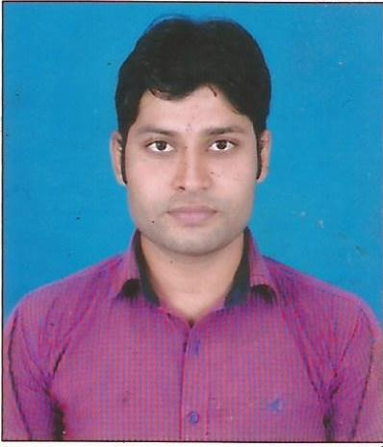

**MD. FAROOQUE AZAM ANSARI**

**Contact No.+91 9504251060**

**Vill- VISHWAMBHARPUR**

**PO.-KUDARBADHA**

**P.S.-GARKHA**

**Email- [mdfarooque72@yahoo.com](mailto:mdfarooque72@yahoo.com) Distt- SARAN,BIHAR**

**CARRIER OBJECTIVE:**

**Objective :** To work with an organization where my potential is fully utilized so that so both grow in a positive direction.

**EDUCATIONAL QUALIFICATION:**

* Graduation (Eng) from JP University in 2013 with 58.25%
* I.Sc.(Math) from BSEB Patna in 2010 with 63%.
* Matriculation from BSEB Patna in 2008 with 50.6%.

**EXTRA QUALIFICATION**

* Advance Diploma In Computer Application from National Computer Centre Chintamanganj Saran 21-03-2012 with 82%

**WORK EXPERIENCE**

Worked in Allahabad Bank Rampur Kadna Saran in post cleark from 2010 to 2013.

**PERSONAL INFORMATION:**

* Father’s Name : Md. Hussain
* Date of Birth : 03-11-1992
* Nationality : Indian
* Sex : Male
* Religion : Islam (Mualim)
* Marital Status : Unmarried
* Languages Known : Hindi & English

**Declaration:**

**I hereby declare that above mentioned particulars are correct and true to the best of my knowledge and belief.**

**Date ……………. Signature**

**Place……………. (Md.Farooque Azam Ansari)**