# RESUME

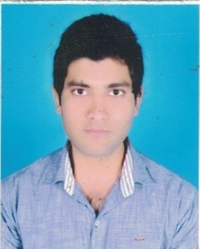

**MD. IMAMUDDIN ANSARI**

**Contact No.+918083395339**

**VILL- VISHWAMBHARPUR**

**PO.-RAHAMPUR**

**P.S.-GARKHA**

**Email:** [**imam.ansari1@gmail.com**](mailto:imam.ansari1@gmail.com) **Dist.- SARAN,BIHAR**

**CARRIER OBJECTIVE:**

**Objective:** To work with an organization where my potential is fully utilized so that so both grow in a positive direction.

**EDUCATIONAL QUALIFICATION:**

* BCA from SMU University in 2011 with 66%
* I.Sc.(Math) from BSEB Patna in 2007 with 56%.
* Matriculation from BSEB Patna in 2005 with 50%.

**WORK EXPERIENCE**

Work as a computer operator in welspun co. India LTD with Oct 2012 to Jul 2013. Anjar (Gujrat)

**PERSONAL INFORMATION:**

* Father’s Name : Md.Hussain
* Date of Birth : 04–10-1990
* Nationality : Indian
* Sex : Male
* Religion : Islam(Muslim)
* Marital Status : Unmarried
* Languages Known : Hindi & English

**Declaration:**

**I hereby declare that above mentioned particulars are correct and true to the best of my knowledge and belief.**

**Date ……………. Signature**

**Place……………. (Md.Imamuddin Ansari)**