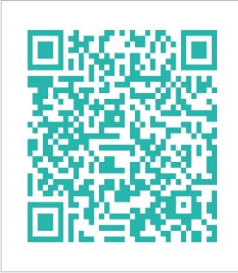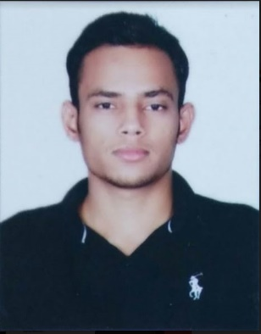



+91.7503385352,870040763000 454888700407630



Aslamkhan750338@gmail.com



Aslamkhank67@gmail.com

**Aslam Khan**

Computer Operator & Data Entry Operator

**ABOUT ME**

**WORK EXPERIENCE**  
4 Years

I Want To Do Work In Any Company Which Provide Me Experience & Help To Learn Different Aspect Of Marketing. Where I Can Utilize My Multidimensional Skills with Punctuality

**AGE**  
23-06-1993



**Education**

|  |  |  |
| --- | --- | --- |
| * B.A | * Delhi University in 2017 | * 49% |
| * 12**th** | * CBSE Board in 2014 | * 76% |
| * 10**th** | * CBSE Board in 2012 | * 70% |



**Professional Qualifications and Affiliations**

* Web Designing . Certificate in CCC . Advanced Excel



**Skills**

.Photoshop, Corel Draw, Power Point, Advanced Excel, Word Typing English & Hindi Typing On GIT Tool

.Knowledge of Accounting like ITR, ITR return file, GST, GST return file, EPFO, ESIC, Documentation, Busy

. Knowledge of Programming Language Html, Css

.Windows XP, 7,8,10 can operate

.Good Knowledge of Internet Surfing, Browsing, Searching & Internet Marketing

.Hardware, Pc Assemble, Software Installations any windows change



**Work Experience**

**Two and Half Years work as a Data Entry Operator and Backend Process From Samm Data Solution Pvt Ltd.**

**6 Month Work from Gadget wood (Yaantra) Eservice Pvt. As an Data Entry executive**

**11 Months Work under C.A (Charted Accountant) In Mycorporatepartner as an Assistant**



**Computer Proficiency**

* Word 2003, 2007, 2013
* Excel 2003, 2007, 2013
* Power Point 2003, 2007, 2013
* Good Command On Typing Speed With Accuracy



**Languages**

* Hindi (Read Write Speak)
* English (Read Write Speak)
* Urdu (Read)



**Personal Interests**

* Arabic (Read)

|  |  |
| --- | --- |
| * Watching Movies | * Learning |
| * Mystery Book Reading |  |
|  |  |



**Personal Details**

Father’s Name: Mr. Salim Khan Marital Status: Single Address: Cl-2/5B Budh Vihar Ph-2   
Birthday: July 06, 1993 Nationality: Indian Delhi-110085  
Gender: Male

**Declaration**

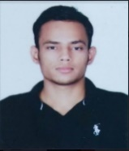I, Aslam Khan, hereby declare that the information contained herein is true and correct to the best of my knowledge and belief.

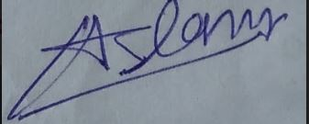   
____________________________ Aug 18, 2018   
 Aslam Khan Delhi India