**Name :** Anshu Kumar Singh 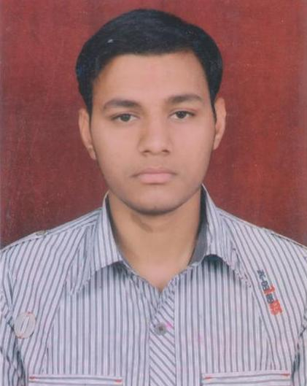

**Mobile no**.  **:** 9953061547,9717721067

**E-Mail Address :** anshukumarsinghh@gmail.com

**Career Objective**

To professionally and technically devote my knowledge and skills to a firm which I have gained through my academic and practical experiences and serve the firm to the best of my potential.

# **Experience**

**Organization** : Bov India Automation,Ghaziabad,UP

**Designation** : Graduate engineer(Engineer-project)

**Duration**  : April 2017-present

Maintenance electrical panel, hydraulic motors ,security system i.e. access control ,analog camera ,IP camera. Monitoring and controlling the site projects.Boom barriers and bollards controlling**.** Worked on integration of UVSS. Hikvision security D-link switch module,.Hard disk installation.working on IVMS-4200 software.Panel wiring and designing,Plc programming.

• Handling of the sites under CMC

• Presentation on different equipment to the client.

• Maintain proper documentation, database,daily, weekly reports etc.

**Project:**

1.Involved in the handling of the CMC of Access Control, Intrusion Alarm System and CCTV system installed at two of the client site.Hikvision NVR system,IP cameras.

 Involved installation/commissioning/integration of various solutions/gadgets like IP camera,bollards boom barrier,access control,RFID based system in Indira Gandhi domestic airport and Indira Gandhi international airport ,Delhi India.

**Organization :** Tak Technologies Pvt. Ltd**.,**New Delhi

**Designation** : Project supervisor

**Duration** : Nov 2015-March 2017

Specialization in automation and security system i.e. analog camera ,IP camera,bollards

Maintenance.monitoring and controlling the site progects.CCTV Surveillance System**:** Worked on installation/integration and commissioning of CCTV surveillance system .

• Handling of field technical team.

• To provide technical support to Customers.

**Organization** : Jindal Aluminium Ltd. Banglore,Karnataka

**Designation** : Electrical Maintenance supervisor.

**Duration** : May 2013 to March 2014 .

Specialization in the Area of Electrical and Automation Field, Working in **Jindal Aluminium Ltd** as an **Electrical Maintenance supervisor**. Monitoring Machine, Method & Material.

Handling of Electrical and Electronics breakdowns.Troubleshooting of fully automated (PLC Based) Hydraulic presses, Pulling Machine,logstands, Videojet Printing m/c, stretching and cutting m/c.

# **Educational Qualification (ELECTRONICS & COMMUNICATION )**

|  |  |  |  |
| --- | --- | --- | --- |
| **Qualification** | **University/Board** | **Month-Year** | **Percentage** |
| B.Tech | CSA University, Kanpur, UP | July 2012 | 70.00% |
| H.S.C | U.P. Board | May 2008 | 67.80% |
| S.S.C | U.P. Board | May 2006 | 63.00% |

# **Industrial Training**

* **INDUSTRIAL AUTOMATION TRAINING AT SOFCON INDIA PVT LTD**

|  |  |
| --- | --- |
| **PLC** | **Allen Bradley Products**:- Micrologix 1000, SLC-503 . **Programming Software**:- RSLogix 500  **Siemens** :- 200, 300  **Programming Software:-** Microwin, Simatic Manager  (Selection, Architecture, Programming, Wiring, Commissioning of PLC). |
| **SCADA** | Wonderware’s Intouch, RS View-32 , (Creating new applications, animation, (communication with PLC ) |
| **HMI** | Allen Bradley Panel View Micro(Creating new applications, animation, communication with PLC). |
| **Drives** | Selection criteria, Working, Controlling, Programming parameters, Energy saving |
| **Instrumentation** | Proximity sensors, RTD, Thermocouple, Flow transmitter etc., Pressure Transducers, Level Sensors |
| **Motors** | Starting methods, Braking, Speed control. |
| **Switch Gears** | Relay, Contactor , MCB , MCCB, ELCB , Breakers. |
| **Panel Design** | Star Delta, DOL, CT, PT, Thermal Overload relay, Wiring etc. |

* **Company**: **DIESEL LOCOMOTIVE WORKS,VARANASI,UP**

**Details** : I was acknowledged with telephone exchange,programmable logic unit.

# **Project**

**Title:** We Design RFID based voting machine

**Team Members:** 5

**Brief: Our project is based on EVM voting machine. We are trying to make this voting machine quite advanced by using radio frequency for identification and hence the project name is ‘RFID based voting machine’ It consist of two main parts RFID reader and RFID tag.**

# **Computer Skills**

* Basics of computer
* Microsoft Office ,power point ,word processing, spread sheet operations, statistical/econometric packages and PPT
* Basics of networking
* Operating system-windows-7,windows-xp,windows-vista

# **Co-curricular Activities and Achievements:**

* **I had qualified written examination of psu companies like Airport Authority of India,HLL ltd,GATE,Nielit,CSIR** .
* Participated in “science Olympiad foundation” at dlw inter college,Varanasi and secured 2nd place on 24th august 2006.
* Won the Runner Up trophy in Cricket Championship which was held at Caet Etawah,

Kanpur.

* Participated in a “Varanasi genius contest” held at sansthan D.L.W.varanasi on 26th august 2007 and secured 1st place.Organized by sansthan D.L.W.,Varanasi.
* Participated in Antakshari,college festival AAHWAAN-2008
* Organize fresher party on August 2011.

# **Personal Profile**

Father’s Name : Narendra Nath Singh

Address : Keshaw Nagar Colony, Lane No.1,D.P.H.

Manduadih,Varanasi,UP

Date of Birth : 30 June 1991

Sex : Male

Marital Status : Single

Nationality : Indian

Languages Known : Hindi and English

Hobbies : Reading Newspaper,Listening Song

I hereby declare that the information given herewith is correct to my knowledge and I will responsible for any discrepancy.

Date:

Place: Varanasi Anshu Kumar Singh