**Resume Cover Letter**

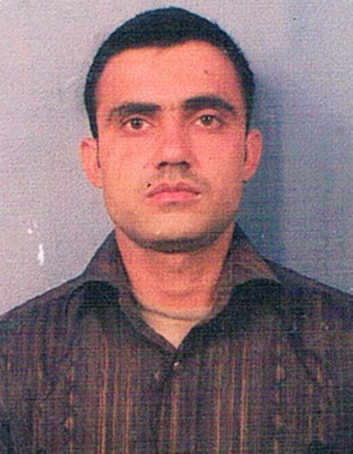

# Prakash Gautam

# Vill-Post: Patlauni

# Distt-Mathura

# UP-281301

**Prakash Gautam**

Contact: +91 9897830191

Email: [1988prakashgautam@gmail.com](mailto:1988prakashgautam@gmail.com)

**OBJECTIVE**

To accomplish prominence through new challenges in a progressive organization that offers opportunities to utilize my skills and dedication to perform quality work. To grow within the industry and be a part of the team contributing, learning & enhancing self-development as a professional and as an individual.

**ORGANIZATIONAL EXPERIENCE**

* **30 DAYS VOCATIONAL TRANING FROM FOUNDER OF GUPTA H.C OVERSEAS(I) PVT.LTD. BYPASS ROAD AGRA.**

**TECHNICAL EXPOSURE**

* **Advanced Diploma in Industrial Safety & Security Management** from IFSE (Institute of Fire & Safety Engineering Nagpur (Affiliated to Maharashtra State board of Technical Education, Mumbai), in the year 2014.

**PRESENT EXPERIENCE**

**FIRE & SAFETY**

Presently Working in **IHC** (India Habitat Centre Lodhi Road New Delhi) from Nov. 2014 to Dec 2016 presently.

**Current** **Designation**:

Working as Fire plant operator, expertise in fire alarm panel, detector and installation.

**Job Responsibilities**

Attend the briefing of all the given reports.

Working as Fire Control Room & Fire pumping Room operator

**Safety**

Hot work – Welding & Cutting (provide and observe safety precautions on site)

**ACADEMIC EXPOSURE**

* **Higher Secondary Certificate :** from U P Board of Allhabad in the year 2004.
* **Bachelor of Art :** from Govt.Collage Institute Of Oriental Philosophy Vrindvan Mathura affiliated with Dr. B.R.A University Agra in the year 2007.
* **Master** **of** **arts(english) :** scored 72% from manav bharthi University in the year 2012.
* **Computer course :** NIELIT course, successfully passed with second class.

**PROJECT UNDERTAKEN**

Title **:** Study of Fix Fire Fighting Installation (FFFI)

Organization **:** GUPTA H.C OVERSEAS (I) PVT.LTD.AGRA

Research Methodology **:** Fix Fire Fighting Installation, Emergency Management plan

duration **:** 30 Days

**PERSONAL DETAILS**

Date of Birth : 16 Aug. 1988

Father’ Name : Mr. Brijmohan Gautam

Languages Known : English & Hindi.

Marital Status : married

Permanent Address : Vill /PO- Patlauni PS- Baldeo Distt-Mathura (UP)-281301

Contact No. : 91-9897830191

Interest : Playing Cricket, Listening Music, reading novels.

Dear Sir,

I am sending my resume for the post of Fire/Safety/Security Officer in your organization.

This is a very interesting opportunity for me and I feel that my educational background and experience will make me a very suitable candidate for this position. My key strengths that meet the requirements of the specified position include:

* I continuously struggle for excellence.
* I have successfully designed, supported, and developed live use applications.
* I offer excellent contributions to company service for all employees.

If you want further information on my experience please see my resume.

You can call me at any time; I am reachable via my cell phone no 09897830191, I further hope to discuss with you about this employment opportunity. Thank you for your time and consideration.

Your's sincerely,

Prakash gautam

Enclosure Resume.

**Date:**

**Place: (Prakash Gautam)**