CURRICULUM VITAE

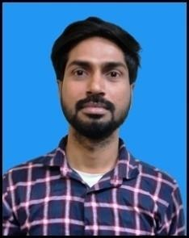SHIVAM SINGH

8799389012 , 7007571720

[shivam.singhmgs@gmail.com](mailto:shivam.singhmgs@gmail.com)

LOT NO 2 MUGHALSARAI CHANDAULI

# Objective

Looking for an organization where I can enhance my knowledge and from my academic learning give my best to the organization.

# Educati~~on~~

|  |  |  |
| --- | --- | --- |
| **COURSE** | **UNIVERSITY/COLLEGE** | **PASSING YEAR** |
| (M.A.) ( Industrial Relations & Personnel  Management) | Mahatma Gandhi Kashi Vidyapith, Varanasi | 2019 |
| B.A | M.G.K.V.P, VARANASI | 2015 |
| INTERMEDIATE | U.P. BOARD | 2012 |
| HIGH SCHOOL | C.B.S.E BOARD | 2010 |

**Summer Internship**

|  |  |  |
| --- | --- | --- |
| **COMPANY** | **DURATION** | **ROLES & RESPONSIBILITIES** |
| HINDALCO RENUKUT | JUNE 4 to  02  AUGUST 2019 | * The project of study undertaken during the training was on the Domestic Enquiry Procedure and Disciplinary Action in H.R DEPARTMENT |

# Industrial Visit

|  |  |
| --- | --- |
| **Place** | **Industry** |
| Varanasi Labour Court | Labour Office Natti Imli |
| Chandauli | Parag dairy |
| Varanasi | MP Biscuit pvt Ltd. |
| Varanasi | Rk Plastic Pvt Ltd. |

Description: -The case studies were done as per academic requirements of (HRM) Mahatma Gandhi Kashi Vidyapith

