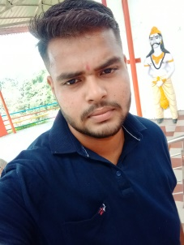

**WORK EXPERIENCE**

Fresher

AMIT KUMAR CHAUDHARY

 **8894523760**

[Amit176021@gmail.com](mailto:Artichoudhary324@gmail.com)



 in.linkedin.com/in/Amit kumar

**ABOUT**

I am a hardworking, honest individual. I am a good timekeeper, always willing to learn new skills. I am friendly, helpful and polite, have a good sense of humor. I am able to work independently in busy environments and also within a team setting. I am outgoing and tactful, and able to listen effectively when solving problems.



**Education**

* B.Sc ( Physics) From H.P University Shimla
* 12th from CBSE New Delhi
* 10th from CBSE New Delhi



**Skills**

* Analysis
* Accounting software
* Computing
* Organization
* Time management
* Communication
* Attention to detail



**Computer Proficiency / Software/website**

* MS Office
* M.s Excel,
* PowerPoint
* Internet Surfing
* Data Entry



**Languages**

* Hindi
* English



**PERSONAL INTERESTS**



Internet Surfing Listening Travelling



**Personal Details**

|  |  |  |  |
| --- | --- | --- | --- |
| Father’s Name: | Subhash Chand | Marital Status: | Single |
| Birthday: | 07.11.1999 | Nationality: | Indian |
| Gender: | Male |  |  |

**Declaration**

I, Amit Kumar Chaudhary, hereby declare that the information contained herein is true and correct to the best of my knowledge and belief.

Amit Kumar Chaudhary Fatehpur, Kangra