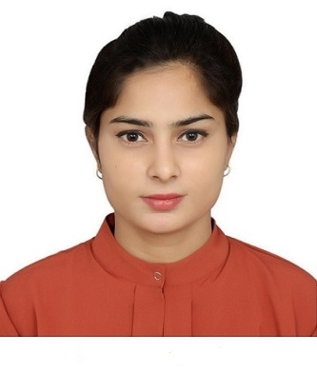

**🚹ABOUT ME**

I Passed a computer diploma in 2014. After that passed 3 years BCA in computers. I have good knowledge of computer software.

**📚QUALIFICATION**

* 10TH Passed from U.P Board in the year 2011.
* 12th Passed from Jamia Board in the year 2013.
* BCA from IGNOU
* Diploma in Aviation, Hospitality and Travel from Frankfinn Institute.
* 1 year Diploma in Computer Application From Al-Ameen Institute.
* Passed CCC exam.

**🖱WORK EXPERIENCE**

* 2 Year Worked as Customer care executive in Samsung Service center
* 8 months Worked as GRE in Raheja Developers.

**Place:- Ludhiana (Chandan Kumar)**

**ARSHI**

**CONTACT**

**Mobile Number**

9310267529

**Email**

[arshik518@gmail.com](mailto:arshik518@gmail.com)

**Address**

A-184 Street no-6 Shaheen Bagh

Jamia Nagar Okhla New Delhi-110025

**SKILL**

* Spreadsheet
* Presentation Tools
* MS office
* Word Processing and Desktop publishing Tools

**PROFILE**

**Father’s Name**

Imran Ahmad

**Date of Birth**

05/08/1996

**Nationality**

Indian

**Religion**

Muslim

**Languageknow**

English and Hindi