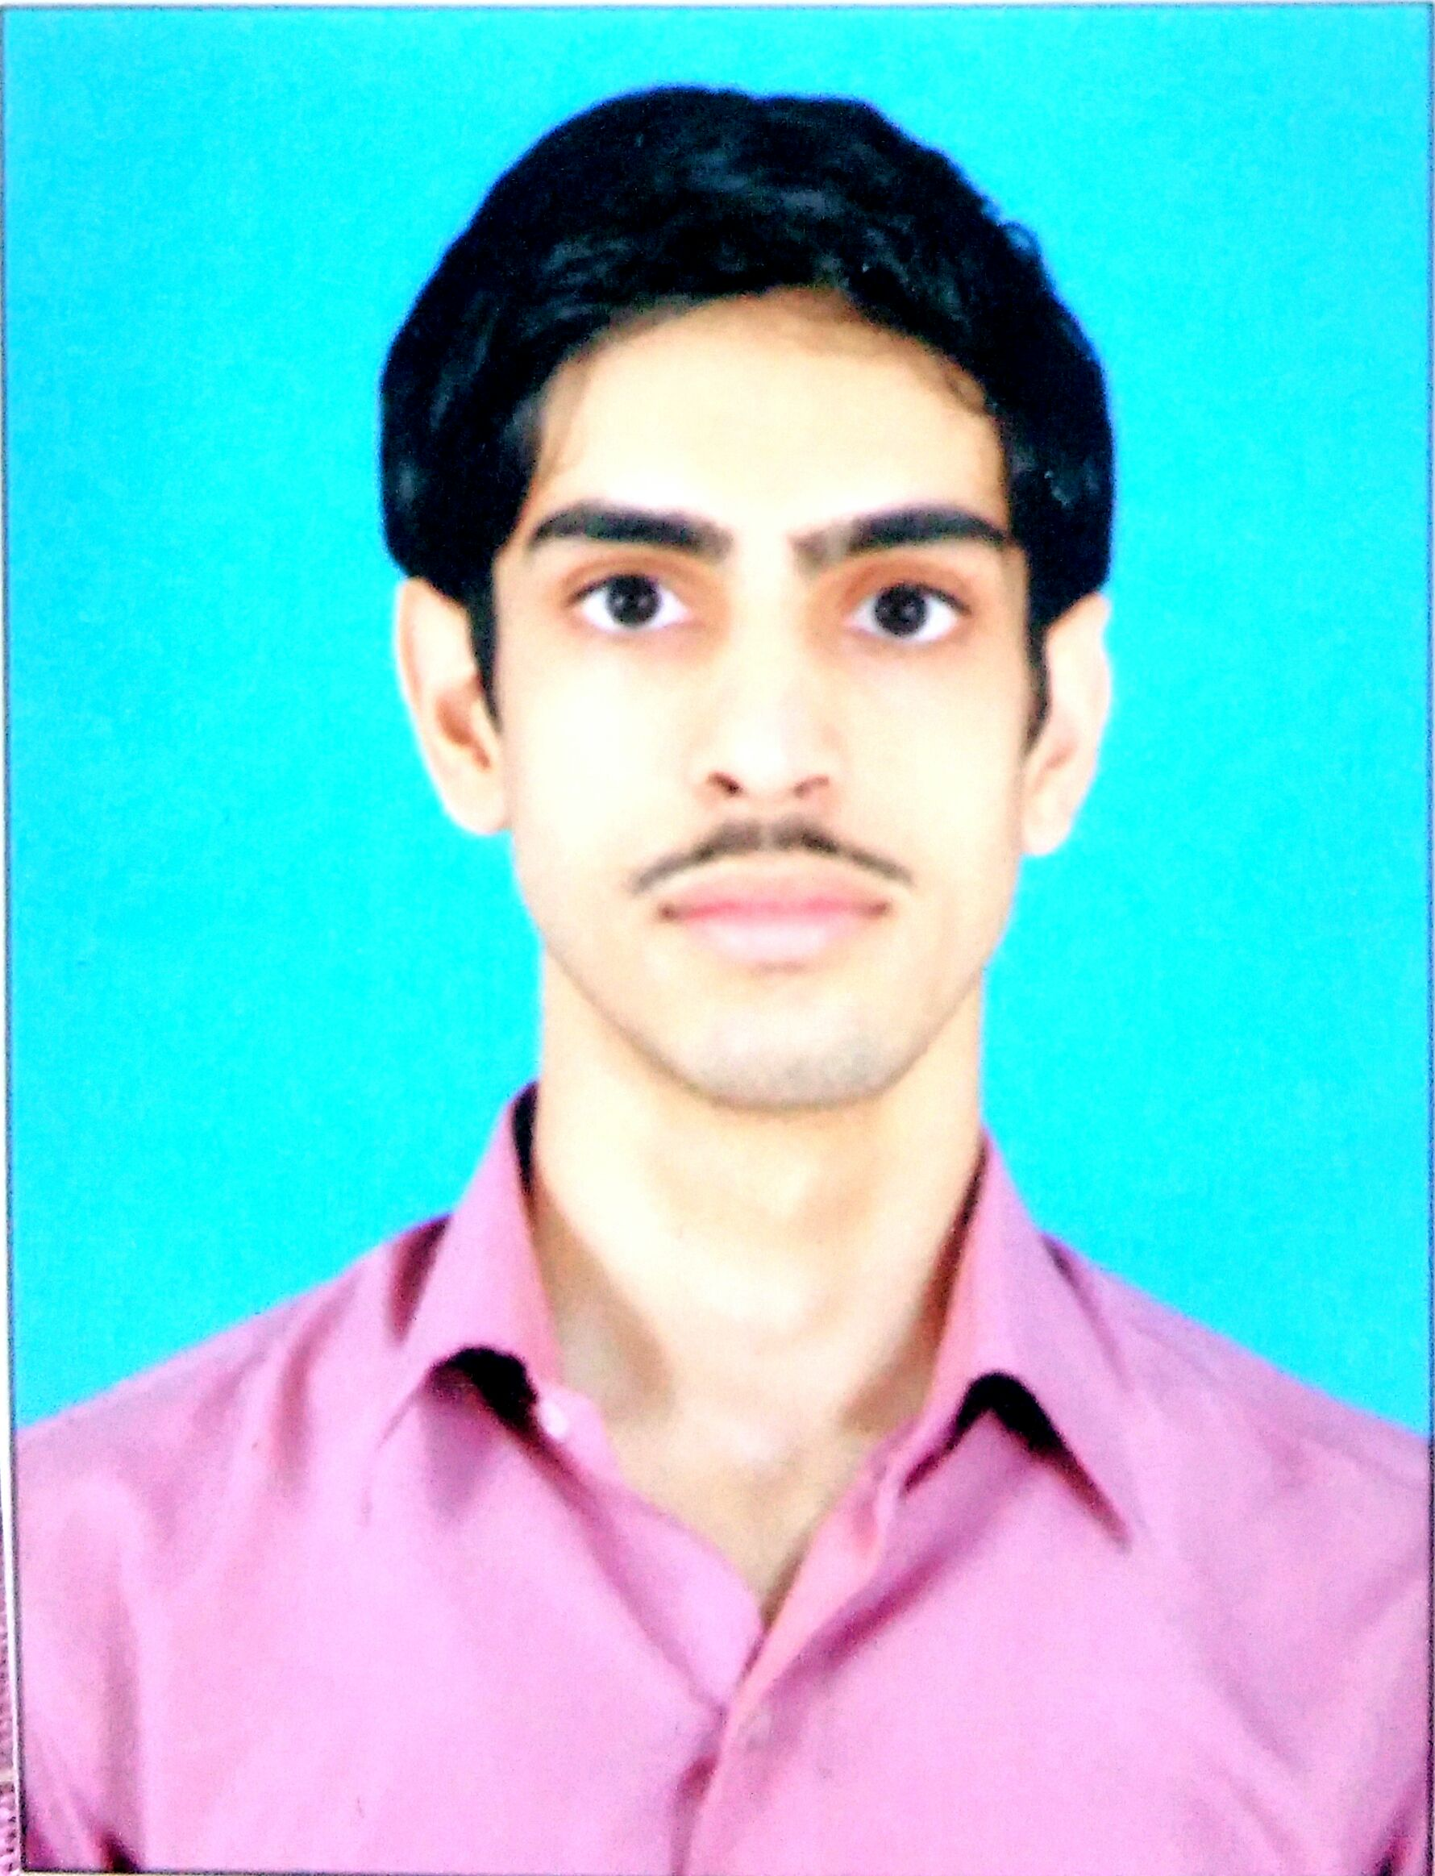

**JATIN KUMAR**

Email : [nogiajatin@gmail.com](mailto:nogiajatin@gmail.com)

Phone no : +91 8447052682, 9582012952

Add : Karol bagh, New delhi 110005

**Career objective**

To be an astute learner and enhance my working capabilities to serve my organization in the best possible way.

**E D U C A T I O N**

**E D U C A T I O N**

|  |  |  |  |
| --- | --- | --- | --- |
| **Degree/**  **Examination** | Year of  Passing | Institute/School | **CGPA/**  **Percentage** |
| Bachelor of Arts ( Program ) | 2020 | Delhi University | _ |
| CBSE (Class XII) | 2017 | GBSS School Dav nagar,  Karol bagh, New delhi | 57% |
| CBSE (Class X) | 2015 | Ramjas school karol bagh , New delhi | 58% |



**T E C H N I C A L S K I L L S**

- MS Office 2013: Excel, Word, Power Point

- Data entry automation certified by NIELIT

- Computer typing skill in English

**E X T R A C U R R I C U L A R A C T I V I T I E S**

- **100% Attendance Certificate** for attending all working days of school. (2016)

- Presentation on topic of history of locomotive and how it’s made. (2019)

**STRENGTH AND OTHER SKILLS / INTEREST**

* Self-confidence, Willingness to learn
* Research & Internet surfing
* Computers & Technology
* Playing badminton
* Reading books