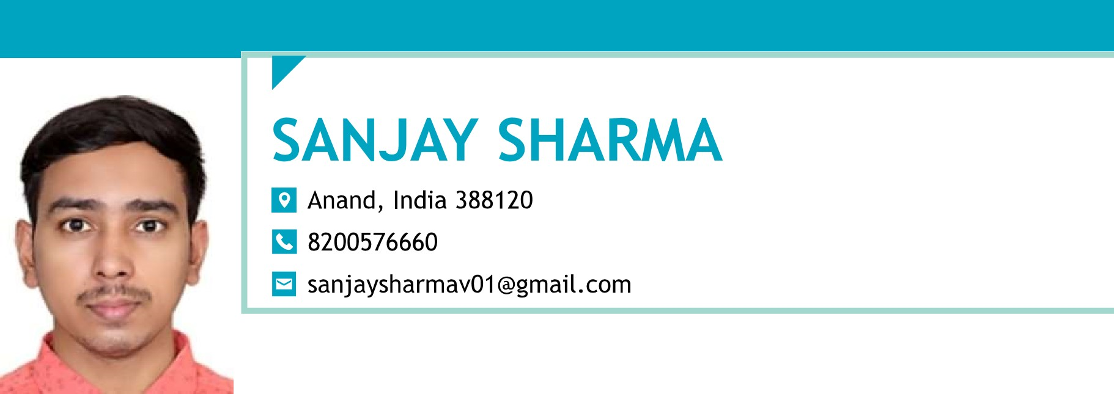

CAREER Seeking an entry level position where I can implement my technical

OBJECTIVE Knowledge and skills acquired through postgraduate studies to realize

My Potential and contribute to the development of the organization.

|  |  |  |
| --- | --- | --- |
| SUMMARY | * Good communication skills with a keen and enthusiastic nature for acquiring   knowledge   * A detail oriented and multitasking professional with exceptional coding techniques and having Master of Science degree [MSc]. * Comprehensive knowledge of primary development languages for instance Python, C++, Java, Linux and special talent of writing highly competent programs. * Excellent understanding of Data Structures and Algorithms. * Statistical Analysis System [SAS], and Data Visualization. * Proficiency in MS Excel, MS Access, also Microsoft Power BI/ Tableau. * I had to also efficiency on data analytics. * Proficiency and working knowledge of SQL. * Deep understanding regarding software development environments and * Considerable talent in achieving critical solution. * Able to understand and implement modern operating systems and great their troubleshooting. * Proactive and collaborative mindset. * Excellent in presenting and make people understand. * Demonstrable ability to motivate and lead others in a team. * Logical bent of mind with the ability to make fact base assumption where required. * Solid proficiency of decision making and problems solving skills. * Understanding of working against the importance of managing deadline. * Passion for result with a challenger mind-set. | |
| SKILLS | * Agile development methodologies * Testing and deployment * SDLC processes * Tools customization * Testing and debugging * Design and development | * Android development * Data Visualization * Data Structures * Microsoft Excel * MySQL |

EDUCATION AND SARDAR PATEL UNIVERSITY, 08/2020 VIDHYANAGAR

TRAINING MSC

CGPA: 5.62

SHREE PM PATEL COLLEGE OF ELECTRONICS & COMMUNICATION,

BSC

CGPA: 6.37

CVM, HIGHER SECONDORY SCHOOL, 03/2014 VIDHYANAGAR

HSC

CGPA :5.56

|  |  |
| --- | --- |
|  | S.D. DESAI HIGH SCHOOL, 03/2012 VIDHYANAGAR.  SSC  CGPA: 6.20 |
| ACCOMPLISHME NTS | CERTIFICATE FOR "UGC SPONSONER STATE LEVEL ONE DAY SEMIN,  Emerging trends and opportunities in interdisciplinary science (2017)  PROFICIENCY CERTIFICATE FOR GENERAL KNOWLEDGE COMPETTI  CERTIFICATE OF APPRECICATION FOR STATE LEVEL QUIZE  COMPETTION  ATTENDED WORKSHOPE ON DATA VISUALIZATION USING  MICROSOFT POWER BI ALSO RECEIVE CERTIFICATE OF THIS. |
| STRENGTH | * Responsible & Caring Nature * Solid Proficiency of decision making * Strong Analytical & Problem Solving skills * Critical Thinking and Business Acumen. * Self-Confident & Self Motivated. * Can adapt to situations & accept responsibilities * Exceptional presentation skills. * Ability to work well in a team. * Excellent Communication skills in written and verbal both. |
| ADDITIONAL | * Enjoy meeting new people, reading and learning new technology * Fluent in English, Hindi and Gujarati. |
| PERSONAL  INFORMATION | Date of Birth : 30-Jan-1995  Hobbies : Listening Music, Internet surfing  Marital Status : Unmarried  Gender : Male |
| LANGUAGES | Gujarati : First Language  English : Advance  Hindi : Proficient |

DECLARATION: I hereby declare that the above mention information is correct up to my knowledge and bear the responsibility for the correctness of the above mention particulars.